CXBanking

OptiNet 10.0

User Reference Guide

**Build Number 2083**

**March 2023**

Copyright and Trademark Information

If this guide is distributed with software that includes an end-user agreement, this guide, as well as the software described in it, is furnished under license and may be used or copied only in accordance with the terms of such license. Except as permitted by any such license, no part of this guide may be reproduced, stored in a retrieval system, or transmitted, in any form or by any means, electronic, mechanical, recording, or otherwise, without the prior written permission of NCR Corporation. Please note that the content in this guide is protected under copyright law even if it is not distributed with software that includes an end-user license agreement.

The content of this guide is furnished for informational use only, is subject to change without notice, and should not be construed as a commitment by NCR Corporation. NCR Corporation assumes no responsibility or liability for any errors or inaccuracies that may appear in the informational content contained in this guide.

OptiCash, OptiNet, OptiVault, OptiCashMI, OptiVLM, OptimizeCF, OptiSuite, OptiRecon, and OptiBridge are trademarks of NCR Corporation.

Adobe Acrobat Reader is a registered trademark of Adobe Systems Incorporated. Microsoft, Windows, and Windows Vista, Internet Explorer (IE) are either registered trademarks or trademarks of Microsoft Corporation in the United States and/or other countries. Solaris is a Trademark or registered trademark of Sun Microsystems, Inc. in the United States and other countries. Oracle is a trademark of Oracle in the United States and other countries. Websphere is a trademark of IBM in the United States and other countries. UNIX is a trademark in the United States and other countries, licensed exclusively through X/Open Company, Ltd. All other trademarks are the property of their respective owners.

Copyright NCR Corporation. All Rights Reserved.

Revision Record

|  |  |  |
| --- | --- | --- |
| Date | Page No. | Description of Change |
| March 2023 | ALL | Formatting Changes |
|  |  |  |
|  |  |  |

Contents

Copyright and Trademark Information 2

Revision Record 3

Contents 4

1 Introduction to OptiNet 6

1.1 Getting Started 7

1.1.1 Conventions used in this Help Documentation 7

1.1.2 Accessing OptiNet 7

1.1.3 Login Process 7

1.1.4 Logout Process 8

1.2 Navigation & the User Interface 9

1.2.1 Main OptiNet Screen 9

1.2.2 Selecting a Cashpoint 10

2 User Types 12

2.1 Administrator 12

2.1.1 Maintaining System Setup 13

2.1.2 Administrative Reports 24

2.2 Cash Analyst 27

2.2.1 Daily Activities for a Cash Analyst 28

2.2.2 Communications 28

2.2.3 Depot Ordering Info 29

2.2.4 Depot Reports 30

2.3 Branch User 31

2.3.1 Daily Activities for a Branch User 32

2.3.2 Communications 33

2.3.3 Consultation 34

2.3.4 Ordering & Clearance 42

2.3.5 Return Pre-Notification 57

2.3.6 Support Information 65

3 Depot User 87

3.1.1 Confirming Depot Orders 87

3.1.2 Depot History 89

4 Security And Authentication 90

4.1 OptiNet Authentication Options 90

4.1.1 Internal 90

4.1.2 External 90

4.1.3 Custom 91

5 Customizing OptiNet 92

5.1 Customizing the ‘Look and Feel’ 92

5.2 Multi-Language Support 92

# Introduction to OptiNet

This chapter provides information on the following topics:

* Conventions used in this Help Documentation
* Accessing OptiNet
* Login Process / Logout Process
* Navigation & the User Interface

NCR's OptiNet application is an intranet application designed for financial institutions using OptiCash as a decision support tool for cost-effective branch and ATM currency management.

OptiNet is an OptiCash complementary intranet application that adds the following functionality to OptiCash:

| Benefits of OptiNet |
| --- |
| **Distributes OptiCash Information via Internet:** Distribute daily cash order recommendations generated by OptiCash from a central location to branch managers and/or entities having currency management responsibilities for their review, acceptance or update, and return. |
| **Collects Daily Cash Order Information:** Collect actual daily cash orders and/or clearances from branches and/or entities having currency management responsibilities to commit original OptiCash cash recommendations or to update the OptiCash database with different cash orders and/or clearance amounts. |
| **Provides Key Information to Your Personnel:** Provide support information to branch managers and/or entities having currency management responsibilities to help them make daily decisions when ordering and/or returning cash for every Cashpoint they manage. This support information, generated and provided by OptiCash, includes historical data, forecasted currency demands, and scheduled deliveries for the next few days. |

## Getting Started

### Conventions used in this Help Documentation

The conventions used in this help documentation are shown in the table below.

Table 1: Conventions

| Convention | Use |
| --- | --- |
| **Green Text** | Indicates a link to the top of the current section. These links can be clicked to quickly navigate through this document. (In some cases you may need to hold the CTRL key to click the link) |
| **Blue Text** | Indicates a link to a different topic or section. These links can be clicked to quickly navigate through this document. (In some cases you may need to hold the CTRL key to click the link) |
| → | The “**arrow**” sign indicates a menu choice. For example, "**Choose File → Open**" means "click the File menu, and then click Open." |
| MCj04338830000[1] | Used to warn users of potential problems or to take caution when making changes to settings and parameters. |
|  | Tips or information that may help use the functionality. |

### Accessing OptiNet

To access OptiNet, you will begin by opening a supported internet browser and entering a URL provided by the OptiNet administrator. This URL can be saved as an item in your *Favorites* folder for easy access to the application.

### Login Process

Once you have entered or selected the required URL, the login screen will appear as shown below. To proceed with login:

1. Enter the Username
2. Enter the Password
3. Click on the Login button

Figure 1: Login Screen>

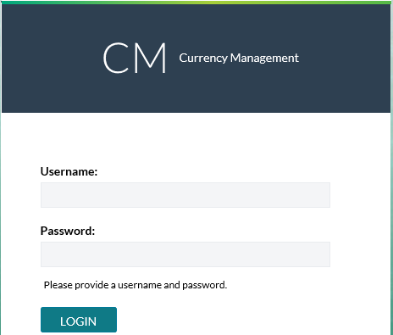

When logging in to the OptiNet Branch and ATMs Cash Ordering and Clearing Intranet Application, a User Name and a Password is required. User names and passwords are managed by an Administrator, who will also be responsible for Cashpoint assignments to each of the users defined in OptiNet. This assignment will determine access rights, so each user will be able to see and update information only for those Cashpoints under his/her responsibility.

### Logout Process

To log out of OptiNet, click **Logout,** located in the top, right-hand corner of the screen.

Figure 2: Branch User Main Screen – Logout

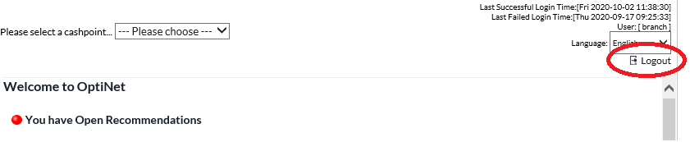

|  |  |
| --- | --- |
|  | **Note**: For external authentication only, simply close your browser to close the application window. |

## Navigation & the User Interface

### Main OptiNet Screen

Once logged in as a valid user, you will have access to the main screen, which is separated into three different frames. The figure below is an example of the Branch User Main screen.

Figure 3: Branch User Main Screen 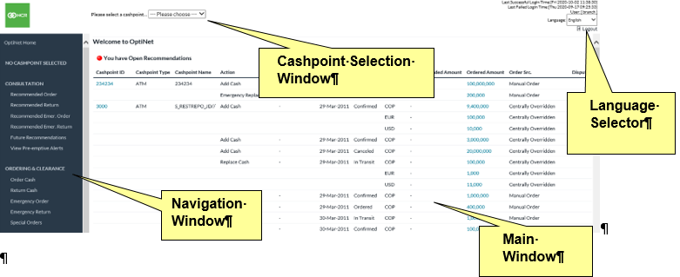

Table 1: Main Screen Components

| Component | Description |
| --- | --- |
| **Cashpoint Selection Window** | At the top of the screen, a frame showing the Cashpoint selector tool where you will see a list of all of the Cashpoints for which you are responsible. You can also select All ATMs, All Branches or All Cashpoints to review a group of Cashpoints for which the user is responsible. |
| **Navigation Window** | On the left side, a frame showing a menu with all of the functions, this intranet application offers currency management. Menu Options are described in detail in subsequent sections. The Navigation Pane is loaded based on the features enabled by the system administrator and the Cashpoint selected. |
| **Main Window** | An interactive frame displays information related to cash orders/returns for Cashpoints. For some options, this frame will let you input information about cash order/return to modify OptiCash generated recommendations, if necessary. Also, this window will let you link directly to outstanding Recommendations and pending Orders. |
| **Language Selector** | The Language Selector is located at the top right line of every page. This allows each user to select the language of choice. |

### Selecting a Cashpoint

To select a Cashpoint, refer to the upper portion of the screen, called the **Cashpoint Selector Window**, as shown in the figure below. Clicking the down arrow will display a list of all of the Cashpoints to which the user has access. The list may include ATMs, Branch IDs, and their respective names.

Figure 4: Cashpoint Selector Window

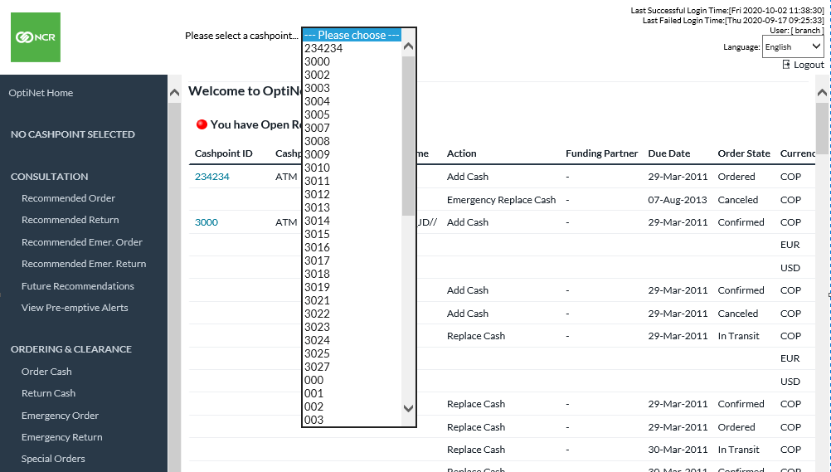

Once you have selected an ATM or Branch, select an option from the **Navigation Window,** shown below in detail for the Branch User. The options that you will see in the **Navigation Window** depend on your user Account privileges, which are determined by your Administrator.

Figure 5: Navigation Window – Branch User

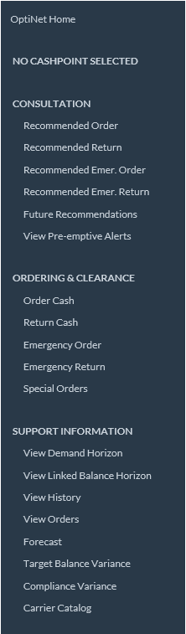

# User Types

There are four different user roles in OptiNet. An overview of each role and its function is presented in this chapter:

* Administrator
* Cash Analyst
* Branch User
* Depot User

## Administrator

The **Navigation Window** for Administrator is displayed below:

Figure 6: Navigation Window -Administrator

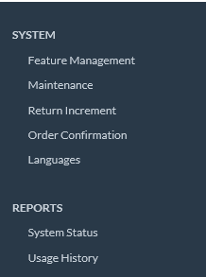

The OptiNet System Administrator’s functions are listed in the table below.

| Administrator Functions |
| --- |
| * Sets and Maintains System Setup * Runs various system reports on System Status, Usage History, and Depot Download. |

### Maintaining System Setup

#### Feature Management

The **Feature Management** option in OptiNet allows you to turn on and off various functions within the application. This configuration is always done at the beginning and is rarely changed after the initial deployment. However, should the circumstance arise, this section covers how to manage the OptiNet features.

1. Click on the **Feature Management** in the Navigation Window.
2. On the OptiNet Feature Managementscreen, note the fields in the following table. Any fields that have a  checked box next to them are currently “**active**.” Any fields without the checked box are currently not active.

| Feature | Description of Feature when Activated |
| --- | --- |
| **ADMIN User Group** | Enables/disables administrator user access to the OptiNet (If the Admin User Group feature is turned off, it can only be reset through the System Properties file). |
| **DEPOT User Group** | Enables/disables Depot User Group access to OptiNet. |
| **Depot Order** | Allows the Depot User to place historical orders. |
| **Depot Confirm** | Allows the Depot User to confirm orders. |
| **Depot History** | Allows the Depot User to review historical information. |
| **ANALYST User Group** | Enables/disables Analyst User Group access to the OptiNet. |
| **Messages / Special Requirements** | Allows branch and cash analyst users to communicate through OptiNet’s messaging and special requirements service. |
| **Analyst Release** | Allows the Analyst User to release orders to the depot. |
| **Analyst History** | Allows the Analyst User to view history. |
| **BRANCH User Group** | Enables/disables Branch User Group access to the OptiNet. |
| **View Batch ATM** | Allows the selection of “**All ATMs**” from the **Cashpoint Selection Window.** |
| **View Batch Branch** | Allows the selection of “**All Branches**” from the **Cashpoint Selection Window.** |
| **View Batch All** | Allows the selection of “**All Cashpoints**” from the **Cashpoint Selection Window.** |
| **Batch Accept Recommendations** | Allows the user to Accept a group of Recommendations. |
| **View ATM Recommended Add** | Allows the Branch User to view “**Add-type**” ATM recommendations. |
| **View ATM Recommended Emergency Add** | Allows the Branch User to view “**Add-type**” emergency ATM recommendations. |
| **View ATM Recommended Replace** | Allows the Branch User to view “**Replace-type**” ATM recommendations. |
| **View ATM Recommended Emergency Replace** | Allows the Branch User to view “**Replace-type**” emergency ATM recommendations. |
| **View ATM Recycler Return** | Allows the Branch User to view “**Recyler-type**” ATM recommendations. |
| **View Branch Recommended Delivery** | Allows the Branch User to view Branch delivery recommendations. |
| **View Branch Recommended Emergency Delivery** | Allows the Branch User to view Branch emergency delivery recommendations. |
| **View Branch Recommended Return** | Allows the Branch User to view Branch return recommendations. |
| **View Branch Recommended Emergency Return** | Allows the Branch User to view Branch emergency return recommendations. |
| **Future Recommendations** | Allows users to see a report with the projected Future Recommendations. |
| **Display Recommendation/Order Units** | Displays the number of units (straps) ordered on the Order confirmation page |
| **View Target Balance** | Enables the Branch user to view the Target Balance. This option will only work if the Calculate Target Balance feature is enabled in OptiCash. |
| **Recommended Clearance Amount Calculation** | Calculates the clearance amount, by denomination, based on the preferred balance split. |
| **Accept ATM Recommended Add** | Allows the Branch User to accept ATM Add Recommendations |
| **Accept ATM Recommended Emergency Add** | Allows the Branch User to accept ATM Emergency Add Recommendations |
| **Accept ATM Recommended Replace** | Allows the Branch User to accept ATM Replace Recommendations |
| **Accept ATM Recommended Emergency Replace** | Allows the Branch User to accept ATM Emergency Replace Recommendations |
| **Accept ATM Recycler Return** | Allows the Branch User to accept ATM Recycler Recommendations |
| **Accept Branch Recommended Delivery** | Allows the Branch User to accept Branch Delivery Recommendations |
| **Accept Branch Recommended Emergency Delivery** | Allows the Branch User to accept Branch Emergency Delivery Recommendations |
| **Accept Branch Recommended Return** | Allows the Branch User to accept Branch Return Recommendations |
| **Accept Branch Recommended Emergency Return** | Allows the Branch User to accept Branch Emergency Return Recommendations |
| **Override ATM Recommended Add** | Allows the Branch User to override ATM Add Recommendations |
| **Override ATM Recommended Emergency Add** | Allows the Branch User to override ATM Emergency and Add Recommendations |
| **Override ATM Recommended Replace** | Allows the Branch User to override ATM Replace Recommendations |
| **Override ATM Recommended Emergency Replace** | Allows the Branch User to override ATM Emergency Replace Recommendations |
| **Override Branch Recommended Delivery** | Allows the Branch User to override Branch Delivery Recommendations |
| **Override Branch Recommended Emergency Delivery** | Allows the Branch User to override Branch Emergency Delivery Recommendations |
| **Override Branch Recommended Return** | Allows the Branch User to override Branch Return Recommendations |
| **Override Branch Recommended Emergency Return** | Allows the Branch User to override Branch Emergency Return Recommendations |
| **Order ATM Add** | Allows the Branch User to view “**Add-type**” ATM orders. |
| **Order ATM Emergency Add** | Allows the Branch User to view “**Add-type**” emergency ATM orders. |
| **Order ATM Replace** | Allows the Branch User to view “**Replace-type**” ATM orders. |
| **Order ATM Emergency Replace** | Allows the Branch User to view “**Replace-type**” ATM emergency orders. |
| **Order ATM Recycler Return** | Allows the Branch User to view “**Recycler-type**” ATM orders. |
| **Order Branch Delivery** | Allows the Branch User to view Branch orders. |
| **Order Branch Emergency Delivery** | Allows the Branch User to view Branch emergency orders. |
| **Order Branch Return** | Allows the Branch User to view Branch return orders. |
| **Order Branch Emergency Return** | Allows the Branch User to view Branch emergency return orders. |
| **Edit Order** | Allows the Branch User to edit existing orders. |
| **Enter Balance** | Allows the Branch User to enter the Balances for Cashpoints. The balance information includes Opening, Closing and daily transactional summary information. |
| **Enter Inner Wallet Types** | Allows users to enter Business Cashsaver entries |
| **Reserve Cash** | Allows the Branch User to create a Reserve Cash request |
| **View History** | Allows the Branch User to view the Cashpoint history report. |
| **View Horizon** | Allows the Branch User to view the Cashpoint horizon report. |
| **View Forecast** | Allows the Branch User to view the Cashpoint forecast report. |
| **View Orders** | Allows the Branch User to view Cashpoint order report. |
| **View Disputes** | Allows the Branch User to view the Disputes report. |
| **Return Increment Validation** | Allows maintaining increment amounts for the returns. |
| **View Utilization** | Provides a report on the utilization of cash in ATMs |
| **View Pre-emptive Alerts** | Allows users to view a pre-emptive alert report |
| **Set ATM Parameters** | Allows users to set the parameters for ATMs |
| **Set ATM Denominations** | Allows users to set the denominations and maximum capacities used in ATMs. |
| **Authorized Item** | This function is no longer available in OptiNet |
| **Return Coin Bags** | Allows users to create Return Coin bags |
| **Create Coin Bags** | Allows users to create Coin bags |
| **Enter Wallet** | Allows users to enter Wallets |
| **Seal and Check Bags** | Allows users to Seal and Check bagged orders |
| **Carrier Pickup** | Allows users to view the bags to be picked up and print the confirmation and signature page |
| **Manage Bags and Wallets** | Allows users to manage bags and wallets |
| **Commercial Ordering** | Allows users to place commercial orders for customers |
| **Commercial Return** | Allows users to place return orders for customers |
| **OptiVLM Carrier Catalog** | Allows users to view Carrier Catalog.  **Note**: This displays details of Carrier Employees and functions only if OptiVLM CarrierWeb is used and reachable by OptiNet. |
| **Recommendation Decline** | Allows the Branch User to decline a recommendation when the user does not want to commit it to an order. |
| **Target Balance Variance** | Allows users to view the Target Balance Variance page |
| **Compliance Variance** | Allows users to view the Compliance Variance page |
| **Allow Transfer Orders** | Allows Branch users to manage Transfer orders |
| **Order Edit Adjustment Entry** | Enabling this feature allows Branch Users when in the Order Edit screen to change the amount “by” an amount rather than “to” an amount.  **For example**, if the Recommendation is for 20,000 and the User wanted it to be 30,000, the user, when this feature is enabled, would Adjust by 10,000 rather than overriding the original amount with the desired revised total. |

1. Click **Save** to save the changes.

#### **System Maintenance:**

The system administrator can also maintain settings for report output as shown in the figure below.

Figure 7: OptiNet Maintenance Screen

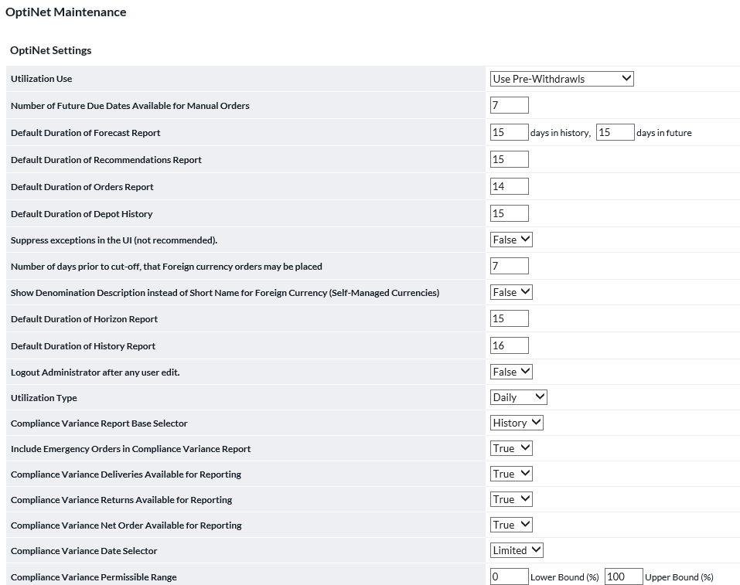

| Feature | Description |
| --- | --- |
| **Utilization Use** | Determines how the Utilization report is calculated. The options are to use the Pre-withdrawal amounts provided in the daily summary data or the Pre-replenishment percentage that is defined at the Cashpoint level. The Pre-withdrawal amount is more accurate but is not always reported in the daily load file. |
| **Default Duration of Forecast Report** | Duration, in days, of the report seen by the Branch user |
| **Default Duration of Recommendations Report** | Duration, in days, of the report seen by the Branch user |
| **Default Duration of Orders Report** | Duration, in days, of the report seen by the Branch user |
| **Target Balance Variance Date Selector** | Choose between:   * **Limited** – ON users will only be able to select the Current or Prior month * **Open** – ON users can select the Current Month, Prior Month, and a flexible date range determined by the user |
| **Default Duration of Depot History** | Duration, in days, of the report seen by the Branch user |
| **Compliance Variance Lower and Upper Bounds** | Set lower and upper variance percentages to define an acceptable variance range |
| **Suppress exceptions in the UI** | Suppresses the stack trace that may be displayed to the user when an error occurs. This can sometimes contain information that institutions do not want their users to access. Suppressing the exceptions will leave users with a generic error message |
| **Compliance Variance Date Selector** | Choose between:   * **Limited** – ON users will only be able to select the Current or Prior month * **Open** – ON users can select the Current Month, Prior Month, and a flexible date range determined by the user |
| **Number of Days Prior to Cutoff that Foreign Currency orders May be Placed** | Foreign Currency orders are placed with optimized currencies. This setting determines the number of days prior to the next lead time cut-off for the optimized currency that the foreign currency can be entered as an order |
| **Show Denomination Description instead of Short Name for Foreign Currency (Self-Managed Currencies)** | Allows the administrator to choose which field is used when displaying the Foreign Currency Denomination Names. The options are:  **False** – Shows the Currency Short Name defined in OptiCash for the Self-Managed Currency Denominations  **True** – Shows the Currency Description defined in OptiCash for the Self-Managed Currency Denominations. |
| **Compliance Variance Deliveries Available for Reporting** | Selects whether Deliveries can be included in the Compliance Variance report |
| **Compliance Variance Net Order Available for Reporting** | Selects whether Net Orders (Deliveries-Returns) can be included in the Compliance Variance report |
| **Default Duration of Horizon Report** | Duration, in days, of the report seen by the Branch user |
| **Target Balance Lower and Upper Bands** | Set lower and upper variance percentages to define an acceptable variance range |
| **Default Duration of History Report** | Duration, in days, of the report seen by the Branch user |
| **Logout Administrator after any User Edit** | A security feature to eliminate the possibility of widespread user changes. When activated, anytime a user is edited, the administrator must log back into OptiNet. |
| **Utilization Type** | Defines the type of utilization to use in the calculation of ATM Utilization. |
| **Compliance Variance Report Base Selector** | History or Orders. The compliance variance report compares recommendations vs. what occurred. This selector chooses which source to use to determine the actual part. |
| **Include Emergency Orders in Compliance Variance Report** | Selects whether Emergency Orders can be included in the Compliance Variance report |
| **Compliance Variance Returns Available for Reporting** | Selects whether Returns can be included in the Compliance Variance report |
| **Future Recommendation Days Actionable** | Number of days in the Future that users are able to perform actions on Recommendations |
| **Maximum Failed Logins** | The limit on the number of failed logins that can occur before the user’s account is locked |
| **Prevent Emergency Order on Planned Delivery Day** | This option when activated prevents emergency orders from being placed on days when a normal delivery day is scheduled. This prevents users from placing a more costly emergency order when a normal order day is available. |
| **Permit Denomination Level Changes** | When activated, the users are able to change the denomination splits while maintaining the total recommendation amount. |
| **Filter Cashpoints By:** | Determines how Cashpoints are sorted. |
| **Cashpoint Listing** | Determines how Cashpoints are displayed.  **Cashpoint ID** – Shows only the Cashpoint ID  **Cashpoint Name** – Shows only the Cashpoint’s Name  **Both** – Shows the Cashpoint Name and ID together. |
| **Order Manifest Type** | Turn on/off or select the type of manifest document that will be produced with Return orders. Branch users will be able to create these documents if one of the Format options is selected. “**Format0**” is default and suitable for most users, while others are specific to certain institutions.  When the Manifest2 type is enabled, the Branch User Order Confirmation screen will show a field called “**Manifest Status**”. It will also include a Red or Green ball. The field indicates whether the amount entered in the Manifest matches the Total Amount of the Order. The Red/Green ball may not be visible to all depending upon the type of Manifest used. |
| **Number of days prior to cut-off that Foreign Currency orders may be placed** | Identifies how many days prior to the delivery date an order can be placed for Self-Managed Currencies. If set to zero, orders can only be placed on the standard order date as determined by the lead time for the order. |
| **CarrierWeb Service URL** | This is a pointer to CarrierWeb installation for use by OptiNet features that need to access CarrierWeb. |

1. Click on Maintenance in the Navigation Window.
2. Under **Report Maintenance**, the administrator can set the number of days to be used in the report generation.
3. Under the **System Maintenance**, Cashpoint-filtering criteria can be set to Cashpoint ID, Name or Both.
4. Click **Save** to save new settings.

#### Return Increment

The system administrator can also maintain increment amounts for the returns as shown in the figure below. This will allow the administrator to override the recommendations considering the increments defined in this window.

Figure 8: Return Increment Screen

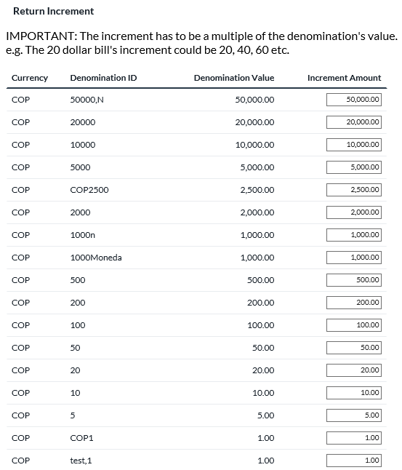

1. Click on **Return Increment** in the Navigation Window.
2. Under the **Increment Amount**, enter the increment sizes for the return.
3. Click **Save** to save new settings.

#### Order Confirmation

The system administrator can configure the order confirmation screen fields, which will be displayed when the user places an order.

Figure 9: Optional Order Confirmation Screen Fields

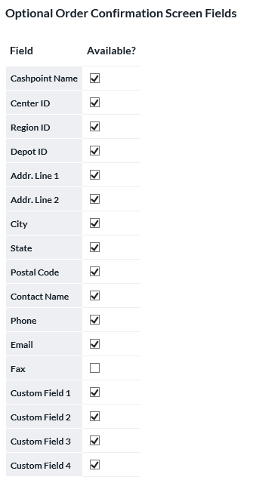

1. Click on **Order Confirmation** in the Navigation Window.
2. Under the **Optional Order Confirmation Screen Fields**, select the fields that you would like to be visible when reviewing orders that have been committed.
3. Click **Save** to save new settings.

### Administrative Reports

Various administrative reports are available, including the following:

| Administrative Reports |
| --- |
| **System Status –** Provides an overview of the system status, OptiNet version, & Institution name. |
| **Usage History** – Lists users who have/not logged in today. Indicates the number of users, user names and last login dates. Click on the hyperlinks to access the user maintenance window. |
| **Depot Download** – Select the format for the balances to be downloaded when received from a depot. There are four possible CSV formats for the download:   * 1. Denomination by row   2. Denomination by column   3. Denomination by Row 4.2.2   4. Denomination by Column 4.2.2   Below is an explanation of the fields in these formats. |

Format 2: Depot Download Denomination by Row 4.2.2 and by Row

| Field | Description |
| --- | --- |
|  | |
| **DEPOT_ID** | A unique alphanumeric identification of the depot. |
| **D_NAME** | Alphanumeric name of the depot. |
| **CASHP_ID** | Cashpoint ID. Unique alphanumeric identification of the Cashpoint. |
| **P_NAME** | Alphanumeric name of the Cashpoint. |
| **CPTYP_ID** | Cashpoint Type. Branch or ATM. |
| **ACTN_ID** | Indicates the type of action depending on the type of Cashpoint:  - **For a branch**: 1 if it is *Delivery* and 2 if it is *Return*.  - **For an ATM**: 1 if it is *Add* or 2 if it is *Replace*. |
| **SCHED_ID** | Indicates the type of schedule:  1 if it is *Planned* and 2 if it is *Unplanned*. |
| **REFERENC** | Reference number of the order that has been committed. |
| **ORD_DATE** | Identifies the date when the order was placed. |
| **DUE_DATE** | Indicates the date when the order is due (considering the lead-time). |
| **DENOM_ID** | Alphanumeric identification for the denomination of the order |
| **DENSHORT** | Identify Notes/Coins defined at the Denomination default level. |
| **DEN_TYPE** | Denomination value defined during the setup process. |
| **DEN_VAL** | A complete description of the denomination value defined during the setup process. |
| **DEN_AMT** | The amount that has been ordered for each denomination |
| The next 3 fields are included ONLY in Format ‘Denomination by Row’ | |
| **CRNCY_ID** | **Currency ID** - Unique alphanumeric value for this currency. |
| **CRNSHORT** | Short description of the currency for that order |
| **PRIORITY** | A unique priority for the currency. The priority of the currencies defines the master/slave relationship for the currencies dispensed at the Cashpoint. The priority of the currency decreases as the numeric value of this field increases. Therefore, the priority value of 1 is the highest and will be defined for the master currency. For any given Cashpoint recommendation process, its master currency drives the optimization/delivery parameters (refer to the example below for more on multi-currency synchronization). |

Example of format Denomination by Row 4.2.2:



Example of format Denomination by Row:



Format 3: Depot Download Denomination by Column 4.2.2 and by Column

| Field | Description |
| --- | --- |
| **DEPOT_ID** | Unique alphanumeric identification of the depot. |
| **D_NAME** | Alphanumeric name of the depot. |
| **CASHP_ID** | Cashpoint ID. Unique alphanumeric identification of the Cashpoint. |
| **P_NAME** | Alphanumeric name of the Cashpoint. |
| **CPTYP_ID** | Cashpoint Type. Branch or ATM. |
| **ACTN_ID** | Indicates the type of action depending on the type of Cashpoint:  - **For a branch:** 1 if it is *Delivery* and 2 if it is *Return*.  - **For an ATM:** 1 if it is *Add* or 2 if it is *Replace*. |
| **SCHED_ID** | Indicates the type of schedule:  1 if it is *Planned* and 2 if it is *Unplanned*. |
| **REFERENC** | Reference number of the order that has been committed. |
| **ORD_DATE** | Identifies the date when the order was placed. |
| **DUE_DATE** | Indicates the date when the order is due (considering the lead-time). |
| The amount of the next fields might vary since they depend on the number of denominations defined in the application | |
| **<DENOMINATION 1>** | If a “**Denomination 1**” is defined in the application, this field will appear in the current file and the value will be the amount that was ordered in that denomination. If no cash was ordered in this particular denomination, the field will be empty. |
| **<DENOMINATION I>** | Same as before. Amount of cash ordered in this denomination |
| **…….** | ……… |
| **<DENOMINATION N>** | Same as before. Amount of cash ordered in this denomination |
| **Note**: In the example at the end of this table, you will see the just-explained fields in italic. They are 500, 200, 100, 50, N00050, etc. They correspond to denominations defined in the application. | |
| The next 3 fields are included ONLY in Format ‘**Denomination by Column’** | |
| **CRNCY_ID** | **Currency ID** - Unique alphanumeric value for this currency. |
| **CRNSHORT** | Short description of the currency for that order |
| **PRIORITY** | A unique priority for the currency. The priority of the currencies defines the master/slave relationship for the currencies dispensed at the Cashpoint. The priority of the currency decreases as the numeric value of this field increases. Therefore, the priority value of 1 is the highest and will be defined for the master currency. For any given Cashpoint recommendation process, its master currency drives the optimization/delivery parameters (refer to the example below for more on multi-currency synchronization). |

Example of format Denomination by Column 4.2.2:



Example of format Denomination by Column:



## Cash Analyst

The **Navigation Window** for Cash Analyst is displayed below:

Figure 10: Navigation Window -Analyst

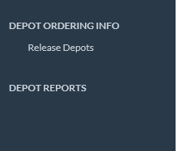

Typically, the Cash Analyst in OptiNet is the primary user in OptiCash as well. The OptiNet Cash Analyst’s functions are presented below.

| Cash Analyst Functions |
| --- |
| * Logs in daily to OptiCash to view and/or modify OptiCash orders, as necessary. * Manages communication with Branch User(s) using OptiNet’s *Communications* functionality. * Logs in daily to OptiNet to release orders to depots. * Reviews depot history as necessary. |

This section presents the following topics on the Cash Analyst User.

* Daily Activities for a Cash Analyst
* Communications
* Depot Ordering Info
* Depot Reports

### Daily Activities for a Cash Analyst

As an OptiNet Cash Analyst User, you will very likely “**float**” between the OptiCash and OptiNet applications during your normal workday. Although every cash analyst may operate slightly differently, per company practices, policies and personal taste, we can offer the following suggested daily list of activities, as a starting point.

| Suggested Flow | Daily Activities Description |
| --- | --- |
| OptiCash Activities | |
| **Review Orders** | Login to OptiCash to review the recommendations for that day. Make any necessary changes to the orders. |
| OptiNet Activities | |
| **Review Messages** | Upon logging into OptiNet, the first task will be to review any new messages and take appropriate action. These messages will come from your Branch User(s) via OptiNet’s *Communications* functionality. |
| **Release Depot Orders** | Review and release orders to the Depots. |
| **Review Messages Periodically** | Throughout the day, check for new messages from your Branch User(s). |

### Communications

The communication module in OptiNet allows Branch Users and Cash Analysts to communicate with each other through *Messaging and Special Requirements* services. The use and features of this module are presented in the following section.

#### View Messages

1. To check for new messages at any time, click **View Messages** in the **Navigation Window.**

|  |  |
| --- | --- |
|  | **Note**: When logged in, the Cash Analyst will immediately be notified of any new messages on the main screen. |

1. To read a new message, click **Review.** The *Message Details* screen will display the From/To parties, date sent, date reviewed, subject and message body.
2. To reply to the message, click **Reply.**
3. To view old messages, click the link **View Old Messages**.

### Depot Ordering Info

The *Depot Ordering Info* functionality is used to release orders to the corresponding depot. The depot cannot view any orders until they are released by the Cash Analyst.

#### Release Depots

1. To release a depot order, first, select **Release Depots** from the **Navigation Window.**
2. Select the depot in the list provided by checking the box and clicking **Release** at the bottom of the screen.

Figure 11: Depot Release Screen

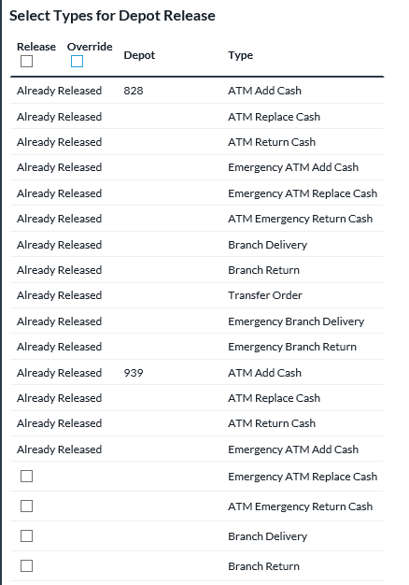

1. On the *Depot Release* screen, note the following fields:

| Field | Description |
| --- | --- |
| **Depot ID** | The alphanumeric value is used for depot identification. |
| **Type** | Type of delivery. Options available: ATM Add Cash, Emergency ATM Add Cash, ATM Replace Cash, Emergency ATM Replace Cash, Branch Delivery, Emergency Branch Delivery, Branch Return, Emergency Branch Return, Commercial Delivery and Commercial Return. |
| **Currency** | Currency ID for which the order is released. |
| **Total Order Amount** | The total amount of orders for Cashpoints associated with this depot. |
| **Order Count** | The number of Cashpoints requesting orders from this depot. |
| **Accepted Recommendation Count** | The number of accepted recommendations for the Cashpoints associated with this depot. |
| **Overridden Recommendation Count** | The number of overridden recommendations for the Cashpoints associated with this depot. |
| **Ignored Recommendation Count** | The number of ignored recommendations for the Cashpoints associated with this depot. |

1. To commit the release, select the type of delivery and click on **Commit.**
2. To cancel the process, select the type of delivery and click on **Cancel.**

|  |  |
| --- | --- |
|  | **Note**: if the Cash Analyst decides to cancel the Release Depot, he/she will communicate back with the branch user to override the order amounts and once the order details are amended, the Cash Analyst will then check the box Override, and release depot. |

### Depot Reports

Depot history can be easily accessed by an analyst from OptiNet. To display depot history, click **Depot History** from the **Navigation Window.** The depot history screen will display the dates of the release and confirmation, the user name of who released and confirmed the order, the total order amounts and the number of recommendations accepted, overridden or ignored. An example of the depot history screen is provided in the figure below:

Figure 12: Depot History Screen

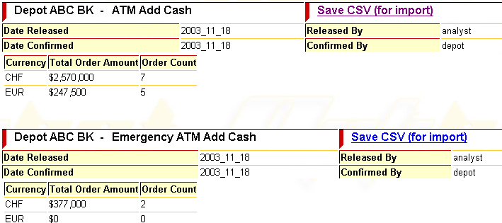

## Branch User

The **Navigation Window** for Branch User is displayed below:

Figure 13: Navigation Window –Branch User

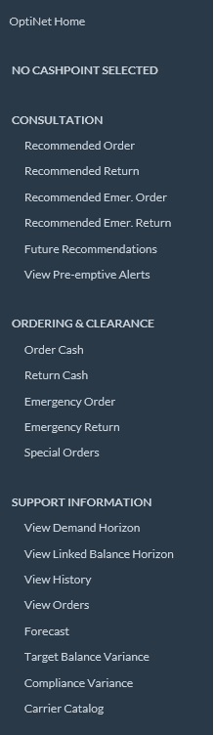

An overview of the Branch User’s functions is presented in the table below:

| Branch User Functions |
| --- |
| * **Communications:** Monitor communications with the various cash analysts. * **Consultation:** Review and accept OptiCash recommendations for branches and ATMs * **Ordering & Clearance:** Order and return cash * **Support Information:** Review demand horizon, history, and forecasts. |

The topics presented in this section on the Branch User include:

* Daily Activities for a Branch User
* Communications
* Ordering & Clearance
* Support Information

### Daily Activities for a Branch User

As an OptiNet Branch User, you now have access to a powerful decision support tool that will help you effectively manage your daily Branch and ATM currency management needs. OptiNet provides you with essential information about your ATM and Branch cash positions. Not only can you access and analyze historical data and usage, but also OptiNet’s web-link to OptiCash allows you to review forecasted cash flows several weeks out – providing a “*snapshot*” of the future.

We suggest using the following routine when performing your daily Branch User Activities:

| Suggested Flow | Daily Activities Description |
| --- | --- |
| **Review Messages** | Upon logging into OptiNet each day, the first task will be to review any new messages and take appropriate action. |
| **Review Recommendations** | Review all OptiCash recommendations for the Branches and ATMs for which you are responsible. |
| **Accept or Reject Recommendations** | After reviewing the recommendations, accept or reject them. |
| **Reference Support Information**  **(Forecasts & History)** | In situations where are you not sure whether to accept or reject a recommendation, use Support Information to help you better understand the recommendations (see below):  **Forecast Graphs**: Reviewing the forecasts graphs will indicate how good the OptiCash predictions have been over the past 2 weeks. The more closely the red and blue lines match, the better the forecast.  **View History**: Reviewing the history of your ATMs and Branches provides information about their cash levels, actual demands, recent deliveries/returns and their frequency. You may notice inaccurate historical data, which will have an adverse affect on recommendations. Inaccurate data can then be easily excluded from the OptiCash history, which will improve recommendations. |
| **View Horizons** | Viewing Cashpoint horizons will allow you to see the OptiCash planned cash level horizons – that is, the optimum cash position that OptiCash has determined for your Cashpoints, based on the predicted cash flows and different parameters defined in OptiCash. Checking these horizons will help you better understand current recommendations and the scheduled deliveries. |

### Communications

The communication module in OptiNet allows Branch Users and Cash Analysts to communicate with each other through *Messaging and Special Requirements* services. The use and features of this module are presented in the following section.

#### View Messages

1. To check for new messages at any time, click **View Messages** in the **Navigation Window.**

|  |  |
| --- | --- |
|  | **Note**: Upon login, the Branch User will immediately be notified of any new messages on the main screen. |

1. To read a new message, click **Review.** The *Message Details* screen will display the From/To parties, date sent, date reviewed, subject and message body.
2. To reply to the message, click **Reply.**
3. To view old messages, click the link **View Old Messages.**

#### Special Requirements

A special requirement communication for a particular Cashpoint can be easily sent through OptiNet, allowing the Branch User to communicate a need for a new mean balance to be established.

1. To send a Special Requirements communication, first select a Cashpoint from the drop-down list in the **Cashpoint Selection Window.**
2. Click **Special Requirement** in the **Navigation Window.**
3. On the *Special Requirement Details* screen, note the **editable** and non-editable fields in the following table:

| Field | Description or Action Required |
| --- | --- |
| **To:** | Click the down arrow and select the appropriate cash analyst from the selection list. |
| **From:** | The Branch User ID will be displayed. |
| **Cashpoint:** | The selected Cashpoint will be displayed. |
| **Requested Completion Date** | Enter the requested completion date for this task. |
| **Requested New Minimum Balance** | Enter the requested new minimum balance for this Cashpoint. |

1. Click **Send Message** once the required fields are completed.

### Consultation

The *Consultation* option allows you to do a daily search for cash order/return recommendations generated by OptiCash for a selected Cashpoint. If OptiCash did not generate cash recommendations for the selected ATM or Branch, a message will be displayed indicating it has no cash recommendations at the current date.

**For ATMs, there are up to five options**: Recommended add, Replace, Emergency add, Emergency replace, and Return.

**For Branches, there are four options**: Recommended orders, Returns, Emergency orders and Emergency returns.

The information for this section is presented in the following sections:

* ATM Recommendations
* Branch Recommendations
* Additional Notes on Overriding Recommendations
* Future Recommendations

#### ATM Recommendations

Displays information about OptiCash’s recommendations for a given ATM at the current date. To view an ATM recommendation, follow the steps below:

1. Select an ATM from the **Cashpoint Selection Window** by clicking the down arrow.
2. Select a recommendation option from the **Navigation Window:**
   * Recommended Add
   * Recommended Replace
   * Recommended Emergency Add
   * Recommended Emergency Replace
   * Recommended Return

|  |  |
| --- | --- |
|  | **Note**: A message will indicate if OptiCash did not generate a recommendation for that ATM for the current date. |

1. If there is an open recommendation for the selected Cashpoint, the following table will be displayed:

Figure 14: ATM Recommendation Screen

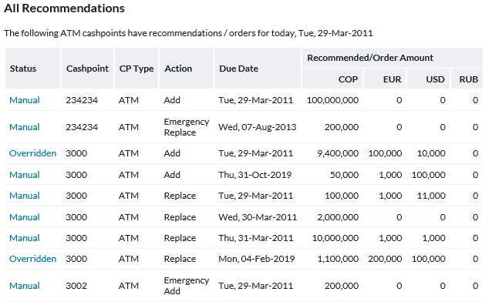

1. The following table will be displayed on the *ATM Recommendations* screen:

Table 2: ATM Recommendation Fields

| Field Name | Description |
| --- | --- |
| **CASHPOINT ID** | The Cashpoint identifier is a string assigned by the institution to identify the ATM (ATM ID). |
| **TYPE** | Cashpoint type is a description of the Cashpoint. Either Branch or Cashpoint will display. (Example ATM recommendation). |
| **REC. DATE** | The date when the ordered amount of cash is to be delivered to the ATM should be prepared at the Vault. That is the date on which the vault should process the ATM cash order. |
| **DUE DATE** | The date on which recommended amount of money will be delivered to the ATM. |
| **ACTION** | For an ATM it will be Add Cash or Replace, whereas for branches Delivery or Return. |
| **DENOMINATION SPLITS (Currency)** | Type of currency being used in ATM. |
| **DENOMINATION SPLITS (Denom.)** | Specific identification is assigned by the institution to each denomination the ATM dispenses. |
| **DENOMINATION SPLITS (Recom. Amt.)** | The recommended amount of money to be delivered to the ATM by denomination. The total recommended amount will be automatically obtained summarizing recommended amounts by currency. |
| **DENOMINATION SPLITS (Ordered Amt.)** | The total amount of money to be delivered to the ATM. The entry can be made to this field if the recommendation has to be overridden or if the denomination distribution needs to be amended from what has been recommended by OptiCash. |
| **DENOMINATION SPLITS (Max. Capacity)** | The maximum amount of money the ATM can hold by denomination. |
| **DENOMINATION SPLITS (Message)** | The branch user can enter a message regarding this order in a free-text field provided for each currency. |

1. To complete the recommendations process, select one of the options below:

| If you want to: | Then follow these steps: |
| --- | --- |
| **Accept** the recommendation from OptiCash | Click **Accept.** A confirmation message is displayed to confirm acceptance.  Once confirmed, a message indicating that the recommendation for the selected ATM has been confirmed is displayed. At this point, the recommendation has been converted to a cash order.  **Caution:** Committed or accepted recommendations cannot be changed. If an order already exists for the same date, an alert message will be displayed. |
| **Override** the recommendation from OptiCash | Click Override.  On the *Override Recommendations* screen, update the **Amount by denomination** and the **Total Amount** will be updated automatically.  If necessary, enter a message regarding this order in the field provided.  Click the down arrow to select an override reason.  Click **Submit** to proceed with this order. |
| **Decline** the recommendation from OptiCash | Branch users can also "Decline" a recommendation. This does not create an order, but marks the recommendation as "declined". If a recommendation is declined, it will no longer show as an open recommendation in OptiCash, the *Today → Snapshot →Ordering Status* chart.  **Note:** The user can go in and accept or override the recommendation later if so desired. To decline the recommendation, click **Decline**. |

#### Branch Recommendations

This option displays information about the OptiCash recommendations for a Branch on the current date. To view a Branch recommendation, follow the steps below.

1. Select a Branch from the **Cashpoint Selection Window** by clicking the down arrow.
2. Select a recommendation option from the **Navigation Window:**
   * Recommended Order
   * Recommended Return (in the case of Returns, users may designate not only by denomination but also the Cash Quality of each denomination)
   * Recommended Emergency Order
   * Recommended Emergency Return (in the case of Returns, users may designate not only by denomination but also the Cash Quality of each denomination)

|  |  |
| --- | --- |
|  | **Note**: A message will indicate if OptiCash does not generate a recommendation for that Branch for the current date. |

Figure 15: Branch Delivery Recommendation Screen

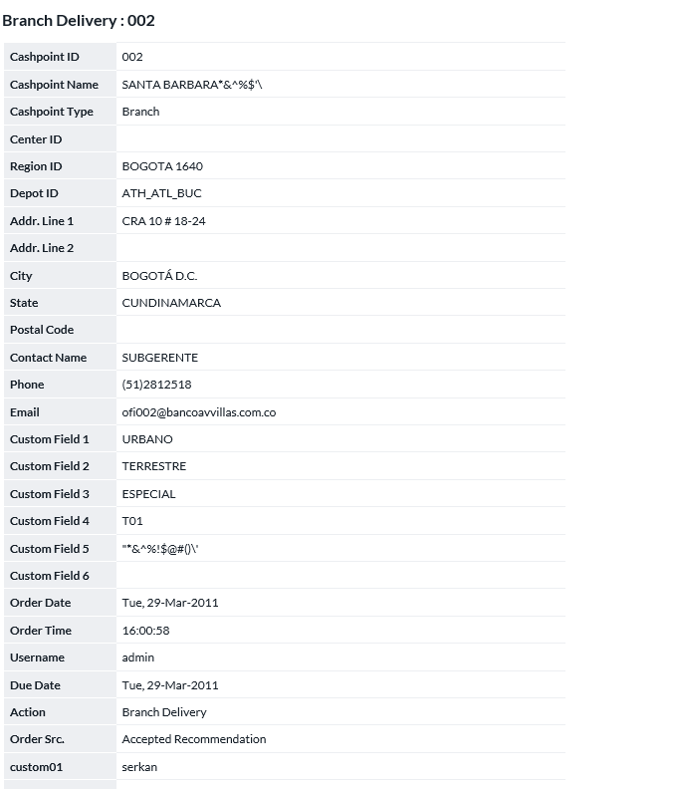

Figure 16: Branch Return Recommendation Screen

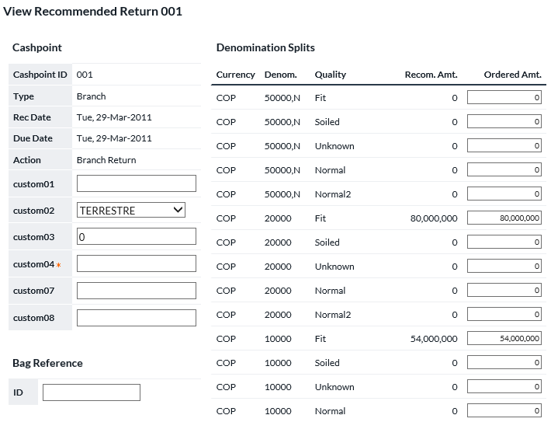

1. If there is a recommendation, the information in the following table will be displayed on the *Branch Recommendations* screen:

Table 3: Branch Recommendation Fields

| Field Name | Description |
| --- | --- |
| **CASHPOINT ID** | The Cashpoint identifier is a string assigned by the institution to identify the branch. |
| **TYPE** | Cashpoint type is a description of the Cashpoint. Either Branch or Cashpoint will display. (Example Branch recommendation). |
| **REC. DATE** | The date on which recommended amount of cash to be delivered should start to be prepared at the Vault to be sent to the Branch, that is, the date on which the vault should receive the Branch cash order. |
| **DUE DATE** | The date on which recommended amount of money will be delivered to the Branch. |
| **ACTION** | For branches, it will be Delivery or Return. |
| **DENOMINATION SPLITS (Currency)** | Type of currency being used in the branch. |
| **DENOMINATION SPLITS (Denom.)** | Specific identification is assigned by the institution to each denomination the Branch uses. |
| **DENOMINATION SPLITS (Quality)**  ***Returns Only*** | Detailed information recording what portion of each currency/denomination belongs to each of the Cash Quality designations being used in the system |
| **DENOMINATION SPLITS (Recom. Amt.)** | The total amount of money to be delivered to the ATM. The entry can be made to this field if the recommendation has to be overridden or if the denomination distribution needs to be amended from what has been recommended by OptiCash. |
| **DENOMINATION SPLITS (Ordered Amt.)** | The total recommended amount of money to be delivered to the Branch. |
| **DENOMINATION SPLITS (Message)** | The branch user can enter a message regarding this order in a free-text field provided for each currency. |

1. To complete the recommendations process, select one of the options in the following table:

| If you want to: | Then follow these steps: |
| --- | --- |
| **Accept** the recommendation from OptiCash | Click **Accept.** A confirmation message is displayed to confirm acceptance.  Once confirmed, a message indicating that the recommendation for the selected Branch has been confirmed is displayed. At this point, the recommendation has been converted to a cash order.  **Caution:** Committed or accepted recommendations cannot be changed. If an order already exists for the same date, an alert message will be displayed. |
| **Override** the recommendation from OptiCash | Click **Override**.  On the *Override Recommendations* screen, update the **Amount by denomination and/or Quality** and the **Total Amount** will be updated automatically.  If necessary, enter a message regarding this order in the field provided.  Click the down arrow to select an override reason.  Click **Submit** to proceed with this order. |
| **Decline** the recommendation from OptiCash | Branch users can also "Decline" a recommendation. This does not create an order, but marks the recommendation as "declined". If a recommendation is declined, it will no longer show as an open recommendation in OptiCash, the *Today → Snapshot →Ordering Status* chart.  **Note:** The user can go in and accept or override the recommendation later if so desired.  To decline the recommendation, click **Decline**. |

#### Additional Notes on Overriding Recommendations

**An example** of the *Override Recommendations* screen for an ATM is shown below. The only editable fields on this screen are the **Ordered Amount** by denominationand **Message** fields**.** When these fields are updated, the **Total Ordered Amount by Currency** is automatically updated. When making changes to individual denomination amounts, be sure to consider the following factors:

* The Maximum Capacity of the Cashpoint
* The Ordered Amount by denomination should be a valid order amount based on the order unit.

Figure 17: Override Recommendation Screen

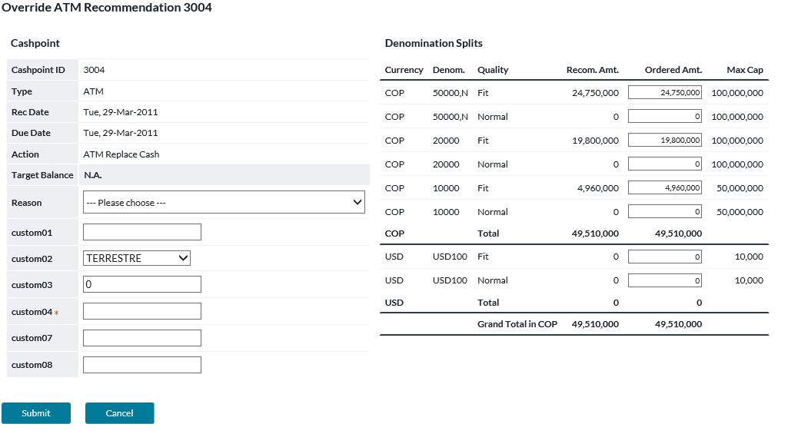

To override a recommendation, select the override reason and update the denomination amount(s).

#### Future Recommendations

The future recommendations for a particular Cashpoint can be reviewed by clicking on the **Future Recommendations** in the **Navigation Window**.

Figure 18: Future Recommendations Screen

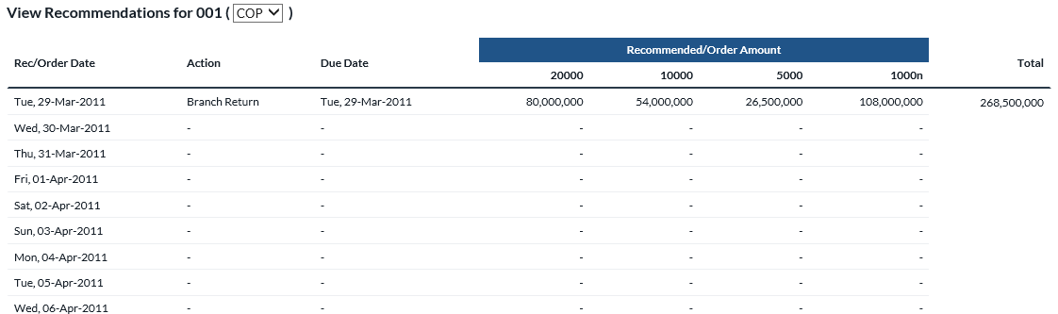

The following table describes the information displayed in the Future Recommendation window:

| Field Name | Description |
| --- | --- |
| **Rec / Order Date** | The date on which recommended amount of cash to be delivered to the Cashpoint should be prepared at the Vault. That is the date on which the vault should receive the Cashpoint cash order. |
| **Action** | For an ATM it will be Add Cash or Replace, whereas for branches Delivery or Return. |
| **Due Date** | The date on which recommended amount of money will be delivered to the Cashpoint. |
| **Recommended / Order Amount** | Recommended/ordered amount of money to be delivered to the Cashpoint (indicated by denomination). |
| **Total** | Total recommended/ordered amount of money to be delivered to the Cashpoint. |

|  |  |
| --- | --- |
|  | **Note**: All today’s and future recommendations can be viewed for all the ATMs and Branches the user is responsible for. To do so, select All ATMs, All Branches or All Cashpoints from the drop-down list in the Cashpoint Selection Window. |

### Ordering & Clearance

The *Ordering and Clearance* options allow you to generate manual orders for Cashpoints in situations where no recommendation has been generated or when an emergency order is necessary. The table below displays the options available under this feature for Branches and ATMs. These options will appear in the **Navigation Window** and will be different depending on whether an ATM or Branch has been selected in the **Cashpoint Selection Window.**

| Ordering & Clearance Option | Description |
| --- | --- |
| ATMs |  |
| **Add Cash** | Manual order to add cash to an “**Add-Cash**” ATM. |
| **Replace Cash** | Manual order to replace cash in a “**Replace-Cash**” ATM. |
| **Emergency Add** | Emergency order to add cash to an “**Add-Cash**” ATM. |
| **Emergency Replace** | Emergency order to replace cash in a “**Replace-Cash**” ATM. |
| **Special Orders** | Special orders are orders placed in OptiNet that do not affect the horizon and optimization of the Cashpoint.  **For example**, an order for a commercial client will not be used in the horizon and will not be accounted for in the recommendation process, because this order was placed not to meet forecasted demand, but a single client request under certain circumstances. |
| **Enter Balance** | Allows OptiNet users to enter or edit the balances for the selected ATM |
| BRANCHES |  |
| **Order Cash** | Manual order to deliver cash to the Branch. |
| **Return Cash** | Manual order to return cash to the vault. |
| **Emergency Order** | Emergency order to deliver cash to the Branch. |
| **Emergency Return** | Emergency order to return cash to the vault. |
| **Commercial Delivery** | Allows users to place orders for delivery directly to Commercial Customers |
| **Commercial Return** | Allows the user to place return orders for returns directly from Commercial Customers. |
| **Special Orders** | Special orders are orders placed in OptiNet that do not affect the horizon and optimization of the Cashpoint.  **For example**, an order for a commercial client will not be used in the horizon and will not be accounted for in the recommendation process, because this order was placed not to meet forecasted demand, but a single client request under certain circumstances. |
| **Reserve Cash** | Obsolete functionality that has been replaced by Commercial Orders |
| **Order Foreign Currencies** | Allows the user to place orders for Foreign Currency Delivery |
| **Return Foreign Currencies** | Allows the user to place orders for Foreign Currency Returns. |
| **Emergency Order Foreign Currencies** | Allows the user to place emergency orders for Foreign Currency Delivery |
| **Emergency Return Foreign Currencies** | Allows the user to place emergency orders for Foreign Currency Returns |
| **Enter Balances** | Allows OptiNet users to enter or edit the balances for the selected Branch Cashpoint |
| **Transfer Order** | This is where you place an order to receive from another Branch (instead of the usual funding source). |

#### ATM Ordering & Clearance

1. To initiate a manual ATM order, first select an **ATM** from the **Cashpoint Selection Window.**
2. The **Navigation Window** in the left portion of the window will update. Select one of the options available under **Ordering & Clearance.**

|  |  |
| --- | --- |
|  | **Note**: For all ATM Ordering and Clearance options (except “**Custody**”), the layout of the screen is the same, as shown in the figure below. |

The field that will differ, depending on the chosen action, will be the **Action** field. From the example below, we know we are dealing with an “**Emergency ATM Add Cash**”.

Figure 19: Manual ATM Order Screen

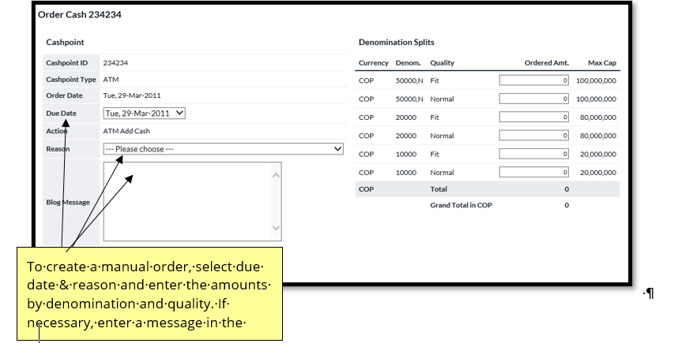

1. Note the fields and descriptions in the following table:

Table 4: ATM Order Fields

| Field Name | Description |
| --- | --- |
| **CASHPOINT ID** | Cashpoint identifier string assigned by the institution. Not editable. |
| **CASHPOINT TYPE** | Cashpoint type is a description of the Cashpoint. Either Branch or Cashpoint will display. |
| **ORDER DATE** | The date on which recommended amount of cash to be delivered to the ATM should be prepared at the Vault. That is the date on which the vault should receive the ATM cash order. Not editable. |
| **DUE DATE** | Select from the calendar object the date on which the ordered amount of money should be delivered to the Cashpoint. |
| **ACTION** | For ATMs, it will be Add Cash or Replace. |
| **REASON** | Dropdown box storing codes to select for changing recommended amount. |
| **BLOG MESSAGE** | Users can enter custom notes that will be attached to and saved with the order detail in OptiCash/OptiNet |
| **DENOMINATION SPLITS (Currency)** | Type of currency being used in the ATM. |
| **DENOMINATION SPLITS (Denom.)** | Specific identification is assigned by the institution to each of the denominations the Cashpoint dispenses. Not editable. Denominations not dispensed by the ATM will not be shown and cannot be ordered. |
| **DENOMINATION SPLITS (Ordered Amt.)** | Type in the amount of money to be ordered for the ATM by denomination. The total ordered amount will be automatically obtained by summarizing individual ordered amounts by denomination. Ordered amounts should not be greater than the respective Max. Capacity per denomination. Denominations not dispensed by the ATM cannot be ordered. |
| **DENOMINATION SPLITS (Max. Capacity)** | The maximum amount of money the ATM can hold by denomination. |

1. To perform the order process, click the down arrow to select a **Due Date** for the manual order.
2. Click the down arrow to select a **Reason Code** for the manual order.
3. Enter the **Ordered Amount** in the **Denomination Splits** portion of the window. The **Total Amount by Currency** field will be updated automatically.
4. If necessary, the branch user can also enter a message regarding this order.
5. Click **Submit.** A confirmation message will confirm that the manual order has been converted successfully.

#### BRANCH Ordering & Clearance

1. To initiate a manual Branch order, first select a **Branch** from the **Cashpoint Selection Window.**
2. The **Navigation Window** in the left portion of the window will update. Select one of the options available under **Ordering & Clearance.**

For all Branch Ordering and Clearance options, the layout of the screen is the same, as shown in the figure below.

The fields that will differ, depending on the chosen action, will be the **Action** field and the presence of Cash Quality designations for Branch Returns only. From the example below, we know we are dealing with a Branch Delivery.

Figure 20: Branch Screen for Delivery

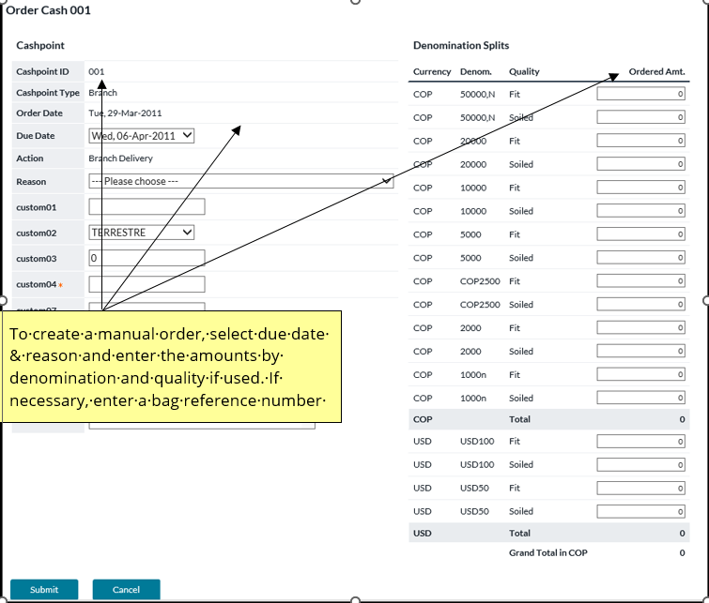

Figure 21: Branch Screen for Clearance/Return

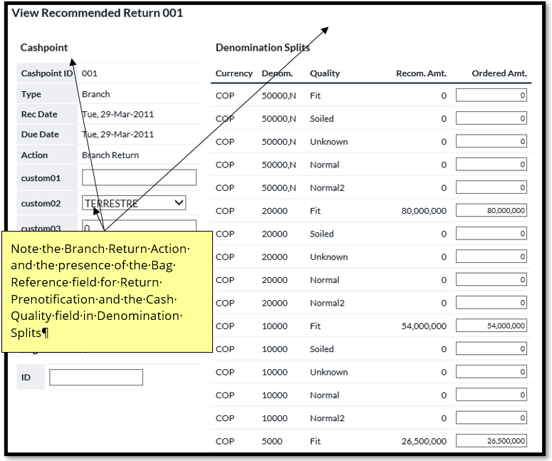

1. Note the fields and descriptions in the following table:

Table 5: Ordering and Clearance Fields

| Field Name | Description |
| --- | --- |
| **CASHPOINT ID** | Cashpoint identifier string assigned by the institution. Not editable. |
| **CASHPOINT TYPE** | Cashpoint type is a description of the Cashpoint. Either Branch or Cashpoint will display. |
| **ORDER DATE** | The date on which the recommended amount of cash should be delivered and prepared at the Vault to be sent to the Branch, that is, the date on which the vault should receive the Branch cash order. Not editable. |
| **DUE DATE** | The date on which recommended amount of money will be delivered to the Branch |
| **ACTION** | For branches, it will be Delivery or Return. |
| BAG REFERENCE ID | **Bag Reference** field will only be displayed for branch returns. In this field, a 12-character bag reference number can be entered for a branch return for tracking purposes. This feature can be turned on or off under the /maint/ URL. |
| DENOMINATION SPLITS (Denomination ID) | Specific identification is assigned by the institution to each of the denominations the Cashpoint dispenses. Not editable. Denominations not dispensed by the Branch will not be shown and cannot be ordered. |
| DENOMINATION SPLITS (Quality) | Allows the designation of what each portion of each currency/denomination belongs to certain Cash Quality designations. |
| DENOMINATION SPLITS (Amount) | Specific identification is assigned by the institution to each denomination the Branch uses. |
| DENOMINATION SPLITS (Max. Capacity) | The recommended amount of money to be delivered to the Branch by denomination. The total recommended amount would be automatically obtained summarizing recommended amounts by denomination. |
| DENOMINATION SPLITS (Message) | The branch user can enter a message regarding this order in a free-text field provided for each currency. |

1. To perform the order process, click the down arrow to select a **Due Date** for the manual order.
2. Click the down arrow to select a **Reason Code** for the manual order.
3. Enter the **Ordered Amount** in the **Denomination Splits** portion of the window. The **Total Amount by Currency** field will be updated automatically.
4. For branch returns only, enter the bag reference ID in the field provided.
5. If necessary, the branch user can also enter a message regarding this order.
6. Click **Submit.** A confirmation message will confirm that the manual order has been converted successfully.

#### Commercial Delivery and Returns

1. To initiate an order to deliver or return cash to a Commercial Customer, first select a **Branch** from the **Cashpoint Selection Window.**
2. The **Navigation Window** in the left portion of the window will update. Select one of the options available under **Ordering & Clearance (Commercial Delivery or Commercial Return).**
3. Select the Commercial Customer Name from the list indicated by the title **Select Commercial Client** and click on Submit button to continue

For all Branch Commercial Ordering and Clearance options, the layout of the screen is the same, as shown in the figure below.

The field that will differ, depending on the chosen action, will be the **Action** field. From the example below, we know we are dealing with a Commercial Delivery.

Figure 22: Commercial Delivery/Return Page

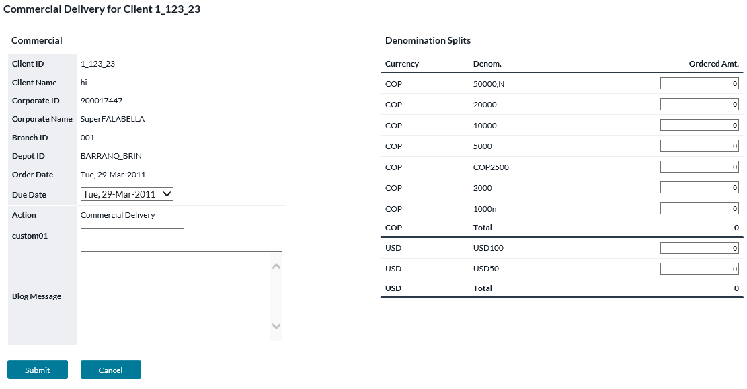

1. Note the fields and descriptions in the following table:

Table 5: Ordering and Clearance Fields

| Field Name | Description |
| --- | --- |
| **Client ID** | Client identifier string assigned by the institution. Not editable. |
| **Client Name** | Client Name as a description of the Client. |
| **Corporate ID** | The ID of the Corporation associated with the client |
| **Corporate Name** | The name associated with the Corporate ID |
| **Branch ID** | The Cashpoint ID of the branch that is placing the order |
| **Depot ID** | The depot or carrier that will deliver or pickup the cash to the commercial customer |
| **Order Date** | The date the order is being placed |
| **Due Date** | By default, the next available due date is available based on the service days and lead times of the Cashpoint that is assigned to the commercial customer. Future dates can be selected from the dropdown list. |
| **Action** | The type of order that is being placed. The possibilities are:  Commercial Delivery  Commercial Return |
| **DENOMINATION SPLITS (Denomination ID)** | Specific identification is assigned by the institution to each of the denominations the Cashpoint dispenses. Not editable. Denominations not dispensed by the Branch will not be shown and cannot be ordered. |
| **DENOMINATION SPLITS (Amount)** | Specific identification is assigned by the institution to each denomination the Branch uses. |
| **DENOMINATION SPLITS (Max. Capacity)** | The recommended amount of money to be delivered to the Branch by denomination. The total recommended amount would be automatically obtained summarizing recommended amounts by denomination. |
| **DENOMINATION SPLITS (Message)** | The branch user can enter a message regarding this order in a free-text field provided for each currency. |

1. To perform the order process, click the down arrow to select a **Due Date** for the manual order.
2. Enter the **Ordered Amount** in the **Denomination Splits** portion of the window. The **Total Amount by Currency** field will be updated automatically.
3. Click **Submit.** A confirmation message will confirm that the manual order has been converted successfully.

#### Foreign Currency Orders & Returns

Foreign Currency order allows users to manage currency levels of additional non-optimized currencies used at the cashpoint.

1. To initiate an order to deliver or return cash to a Commercial Customer, first select a **Branch** from the **Cashpoint Selection Window.**
2. The **Navigation Window** in the left portion of the window will update. Select either **Order Foreign Currencies** or **Return Foreign Currencies** under **Ordering & Clearance.**
3. The screen will refresh, and the user will click on **Create New Order.**
4. Upon screen refresh, the user is able to select a due date, and an override reason, and fill in any mandatory custom fields that may be in use. Select **NEXT** at the bottom of the screen.
5. The screen will refresh again, Click **ADD** which will open a popup where the user can select a currency and amounts by each denomination for that currency. The user can select **BACK**, step backwards for editing, **ACCEPT** to complete that currency, or **CANCEL** to delete the entries and close the screen.
6. Once all currencies have been entered per the steps in #5, the user can select **FINISH** and the Foreign Currency Order process will be completed.

Figure 23: Foreign Currency Order Screen

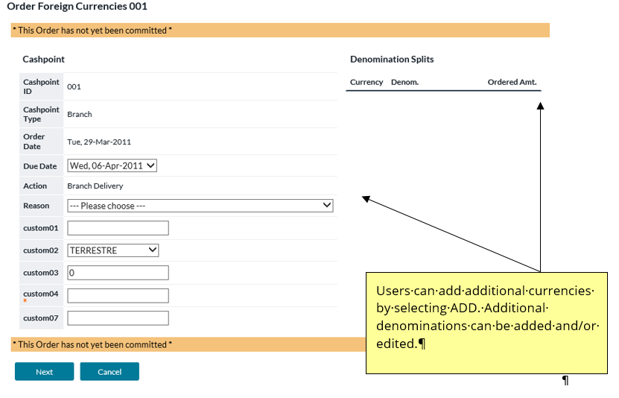

#### Branch Foreign Currency Orders (Self Managed Currencies)

The Self-Managed Currency Module of OptiNet and OptiCash allows the user to place orders for Non-Optimized Currencies. Self-Managed currencies do not have balances and do no receive recommendations for orders. They are placed on an as-needed basis by the branch user.

1. Select the Cashpoint for which foreign currencies will be ordered. Once selected, the left navigation pane will load with the ordering functionality specific to the Cashpoint type.

**Note:** Foreign currency can only be ordered for Branch Cashpoints; therefore, this functionality is not available when selecting an ATM.

1. Select the appropriate link from the left navigation pane under the section called “**Ordering & Clearance**”. The available options are:
   * Order Foreign Currencies
   * Return Foreign Currencies
   * Emergency Order Foreign Currencies
   * Emergency Return Foreign Currencies
2. Once selected, the window will refresh with the Order Foreign Currencies Page.
3. The following fields are displayed on this page:

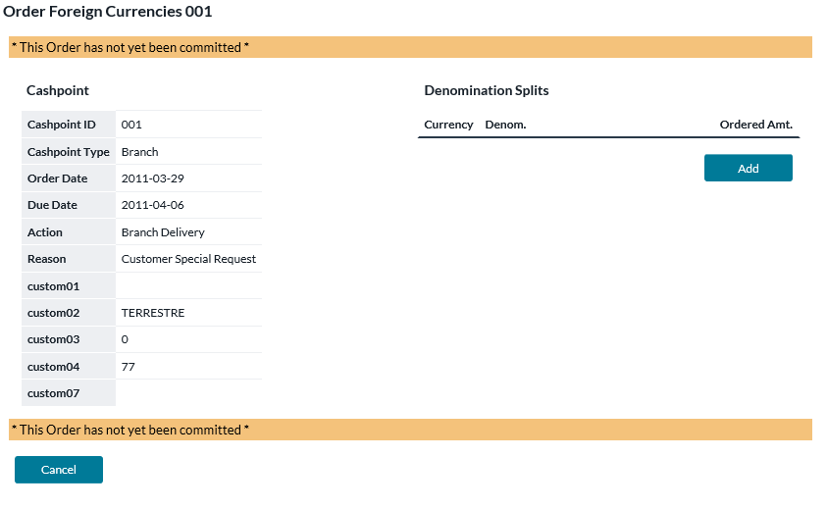

| Field Name | Description |
| --- | --- |
| **CASHPOINT ID** | Cashpoint identifier string assigned by the institution. Not editable. |
| **CASHPOINT TYPE** | Cashpoint type is a description of the Cashpoint. Either Branch or Cashpoint will display. |
| **ORDER DATE** | The date on which recommended amount of cash to be delivered should start to be prepared at the Vault to be sent to the Branch, that is, the date on which the vault should receive the Branch cash order. Not editable. |
| **DUE DATE** | The date on which recommended amount of money will be delivered to the Branch |
| **ACTION** | Action for either a Delivery or Return. |
| **REASON** | Dropdown box storing codes to select for executing the Foreign Currency Order |
| **DENOMINATION SPLITS (Currency)** | The Currency Identifier for the specific currency selected. |
| **DENOMINATION SPLITS (Denom.)** | Specific identification is assigned by the institution to each of the denominations the Cashpoint dispenses. Not editable.  The available currencies to be ordered are set up in OptiCash and it is possible to show either the ‘Short Name’ or the ‘Description’ for the Foreign Currency. The administrator must decide which option will be used in OptiNet. |
| **DENOMINATION SPLITS (Ordered Amt)** | Amount of the denomination that has been ordered |
| **DENOMINATION SPLITS (Message)** | The branch user can enter a message regarding this order in a free-text field provided for each currency. |

1. Select the Due Date from the dropdown menu. 

**Note:** The available delivery dates correspond with available delivery dates based on lead times set in OptiCash. If specific lead times have not been specified at the Cashpoint level in OptiCash, the lead times and days for Optimized Currencies will apply.

1. Select an Override Reason for this order. 

The Override reasons are set up by the administrator in OptiCash. Please talk to an administrator if the correct override reason is not available.

1. Click the ‘**Next’** button to add currencies to the order.
2. To select denominations that will be ordered, click the ‘**Add’** button under the ‘**Denomination Splits**’ section of the page. A popup window will appear to allow the user to select the currencies and denominations to order.
3. Choose a currency from the dropdown list box under the Currency column. The list will contain only those currencies that can be ordered based on the lead time for the currencies and the ‘**Due Date**’ selected. (i.e. If the next day was selected as a due date, but there is a Foreign Currency with a 2-day lead time, it will not be displayed in the list of currencies.)
4. Choose a denomination from the dropdown list box located under the ‘**Denomination’** column. The list of denominations will be based on the currency selected.
5. Enter the Amount to order for the selected currency and denomination.
6. Click the ‘**Submit’** button to add the denomination to the order.
7. Optionally, the user can click on the ‘**Message’** button to enter a message for the order. A different message can be entered for each Currency (not denomination).
8. Repeat the adding process until all currencies and denominations have been ordered.
9. Click the ‘**Finish’** button to confirm the order.

#### Editing Foreign Currency Orders

Foreign Currency Orders can be modified on the day the order is placed by selecting the appropriate Order Type (Normal or Emergency Delivery or Return).

Upon selecting the Order Type, the existing orders page will be displayed, the user can edit the existing order or place a new order. To edit the order, perform the following steps:

1. Click on the hyperlink of the Cashpoint ID that corresponds to the order that is to be edited.
2. The Confirmation page for the order will be displayed. Click the ‘**Edit’** button to enter the order.
3. Perform the necessary changes to the order and click the ‘**Finish’** button to complete the order.

#### Order Custom Fields

Order Custom Fields allow users to enter additional information for the order that is not part of the normal ordering process (i.e. Department Number). These fields can be assigned at the system level to apply to any or all types of orders

Figure 24: Order Custom Fields on THE Orders Overview Page



Table 4: Order Custom FieLD Description

| Fields | Description |
| --- | --- |
| **Custom01 – Custom10** | Custom Fields that can be used to collect data about the order that is not part of the normal ordering process. Two types of fields can be made available to the user for the custom fields:   * **Free Text** – a box to allow users to type in any information necessary that applies to the Custom field * **Custom List** – A list of items to choose from In either case information can be entered and then stored with the order for use in the output of the data. |
| **Custom01 * - Custom10 \*** | The Starred Items in the Custom fields indicate that the Entry is mandatory and an item must be selected or entered before the order can be processed. |

#### Order Workflow (Blog and Trace)

Order Workflow is a separately licensed functionality that is used to help users manage the State of an order from the time it is created until the time it is delivered. Workflow rules can be set up by an administrator in OptiCash. Additionally, analysts can keep a Blog history of notes about the order to be able to share information about the orders and improve communication between analysts and users.

Figure 25: Order Workflow Page

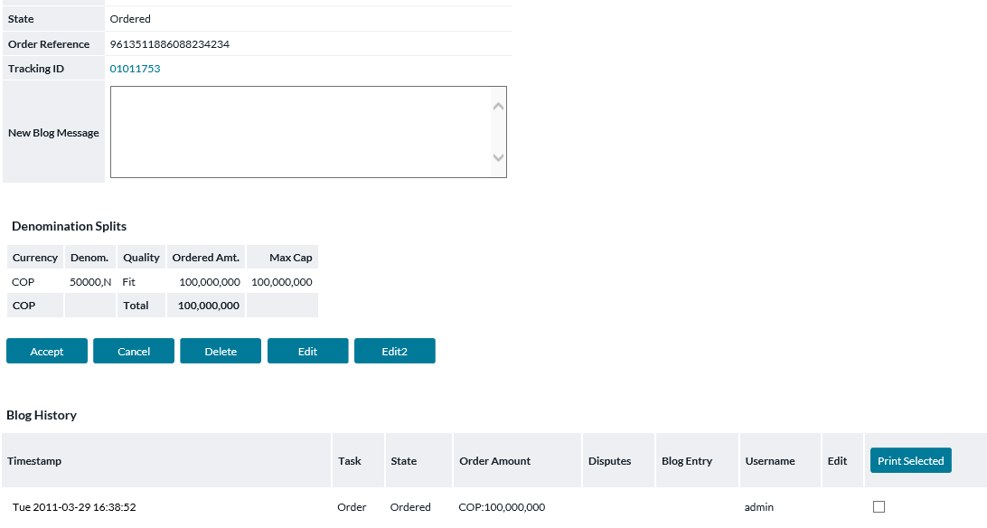

Table 5: Order Workflow Description

| Fields | Description |
| --- | --- |
| **State** | Indicates the current state of the order. The State of the order is determined by the workflow setup by the Administrator |
| **Message** (if applicable)  (Ordered Denominations Panel) | The user can also enter a message in a free-text field for each currency in order. This message will be sent to users through OptiNet. This feature can be turned on or off depending on the needs of the bank. Please consult the administrator's guide for more information. |
| **Tracking ID**  (if applicable) | A Tracking ID is generated and assigned to all orders that are due on the same day. The assumption with the Tracking ID is that it is used for tracking orders on the same truck that come in together. If an order needs a separate ID, the Order Tracking ID can be replaced by clicking on the ID. |
| **Master Order Reference Number** | This is a Reference number that is used to track a specific order. This number cannot be changed and is static to the order |
| **Blog History** | Details the History of Blog Notes placed for the order |
| **New Blog Message** | Users can enter a new message for the order that will be placed in the Blog History. The Analysts can review the notes when reviewing the order. |
| **Next Action buttons** | The buttons at the bottom of the page give the user the option to move the order to a new state. These buttons become visible based on the users rights and the current state of the order. |

#### Order Tracking ID

This page is accessed from the *Order Overview page* and is used to change the Tracking ID for a particular order. By default, all orders that are due on the same day receive the same Tracking ID.

Figure 26: Edit Tracking ID Page

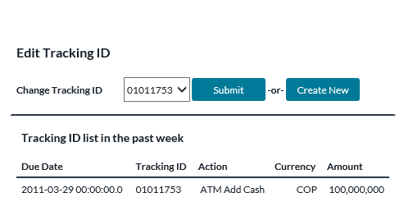

Table 6: Edit Tracking ID Description

| Fields | Description |
| --- | --- |
| **Change Tracking ID** | Lists the Available Tracking ID that can be assigned to the Order. The available Tracking IDs can be selected from the dropdown list and assigned by clicking the ‘**Submit’** button |
| **Submit Button** | Makes the change of the Tracking ID to the Tracking ID selected in the drop-down list to the right of the button |
| **Create New button** | Generates a new Tracking ID for the order |
| **Due Date** | Date the Order is due of the order placed in the last week |
| **Tracking ID** | Details the Tracking ID for the order placed in the last week |
| **Action** | Describes the action of the order placed in the last week |
| **Currency** | Describes the currency of the order placed in the last week |
| **Amount** | Describes the amount of orders placed in the last week |

### Return Pre-Notification

OptiNet users can utilize the Pre-Notification functionality within OptiNet to alert the Carrier of upcoming returns of cash or other items. This functionality is only available for Branch Cashpoints.

Below is the workflow for Return Pre-Notification which will be covered in the following sections:

1. Inner Wallet and Coin Bag definitions must be created in OptiCash by the OptiCash administrator. This needs to be done once to set up the Wallet Type IDs that will be visible in OptiNet.
2. Create any applicable Coin Bag entries.
3. Create Outer Container Bag entries.
4. Create Inner Wallet entries.

**Note:** The creation of Coin Bags, Outer Container Bags, and Inner Wallets can be done in any order by OptiNet users.

1. Seal and Check bags to be returned. This means recording which Inner Wallets are inside which Outer Bags. Once the wallet/bag assignment is complete, OptiNet users will want to mark each bag as Sealed and will be provided with a printable report for each Bag at that point. Coin Bags do not need to go through this step.
2. Carrier Pickup. After bags for a particular return trip are all Sealed, OptiNet users should go to the Carrier Pickup screen for a printable document to accompany the return trip. They may also mark bags as Sent at this point.
3. Manage Bags/Wallets. This page provides OptiNet users with a high-level, searchable view of pre-notification records, audit info, and printable reports regarding those. It may be useful at any stage after record creation, including after containers are Sent.

#### Coin Bag Creation

Coin Bags are typically characterized as simple bags containing only coins. It is not necessary to enter Outer Bag/Inner Wallet records for Coin Bags.

Begin entering a coin bag by clicking on the Return Coin Bag link in the left menu.

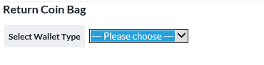

Users will first be asked what type of coin bag to create.

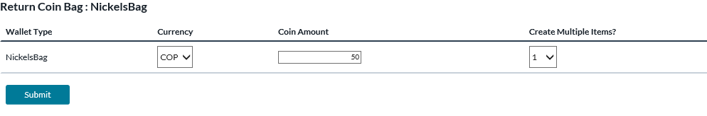

Enter the relevant info regarding the coin bag(s) to be returned. The coin Amount is the total value of 1 bag. If multiple identical bags are to be created, select the number in Create Multiple Items field. ID numbers will be created automatically for the coin bag(s) once submitted.

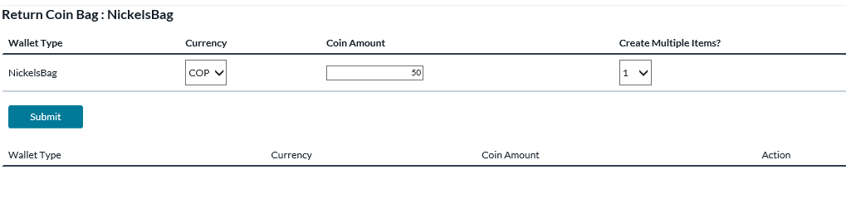

Upon submission, the coin bags appear in the lower section of the page. The user may enter more coin bags, or delete existing coin bags. Once coin bags are marked Sent, they disappear from this page.

#### Outer Container Bag Creation

The *Outer Container Bag* is a reference number that is used to identify the main transport container that will be used to return Inner Wallets.

Begin entering Outer Container Bags by clicking Create Container Bag link in the left menu.

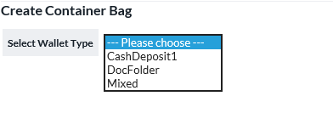

Users will first be asked what type of Outer Container Bag to create. If a specific type is chosen, then only Inner Wallets of that type may be placed inside the bag. If intending to place Inner Wallets of more than 1 type within this Outer Container Bag, choose the Mixed option.

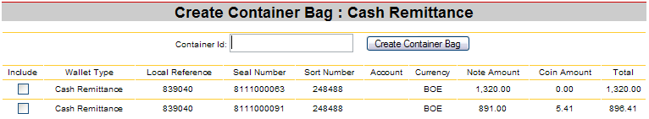

All that is required to create an Outer Container Bag is a unique ID number. Optionally, users may also select Inner Wallets that are contained inside the Outer Container Bag that is to be created.

#### Wallet Entry

Inner Wallets are smaller containers with notes and/or coins that will be placed within an Outer Container Bag for transport.

Begin recording Inner Wallets by clicking Enter Wallet in the OptiNet left menu.

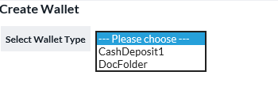

Users will first be asked what type of Inner Wallet to create. These types are defined initially by the OptiCash administrator.

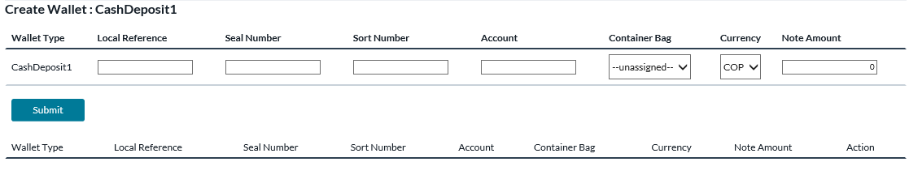

Upon selecting an Inner Wallet type, users will be presented with the above screen for recording the Inner Wallet. The lower area of this page is used to display previously recorded wallets that have not yet been Sent. Fields on this page are explained in the table below.

**Note:** Not all fields may be available, according to the OptiCash administrator’s settings.

| Field Name | Description |
| --- | --- |
| Wallet Type | Pre-defined in OptiCash by the OptiCash administrator; these entries identify the type of Inner Wallet to be transported. |
| Local Reference | The alphanumeric field for local use |
| Seal Number | Unique alphanumeric value to identify the Seal on the Wallet. |
| Sort Number | The number used by the bank for sorting purposes. This should be 6 digits or left blank. |
| Account | The number used to identify the account of the wallet. This should be 8 digits or left blank. |
| Container Bag | The reference number for the Outer Bag Container will be the container for the Wallet. |
| Currency | The Currency of the notes and/or coins within the Wallet |
| Note Amount | Value of the notes in the Wallet |
| Coin Amount | Value of the coins in the Wallet. |
| Total | The total value of the Wallet (Automatically calculated) |
| *NOTE* | Not all of the above fields may be available, based on the OptiCash administrator’s settings. |

#### Seal and check bags

After the initial container entry, the next step in the return pre-notification workflow is to prepare bags for shipping. This typically involves making sure that all Inner Wallets are assigned to Outer Container Bags and then marking the Outer Container Bags as Sealed and ready for transport.

Begin preparation for shipping by clicking on the Seal and Checking the link in the OptiNet left menu.

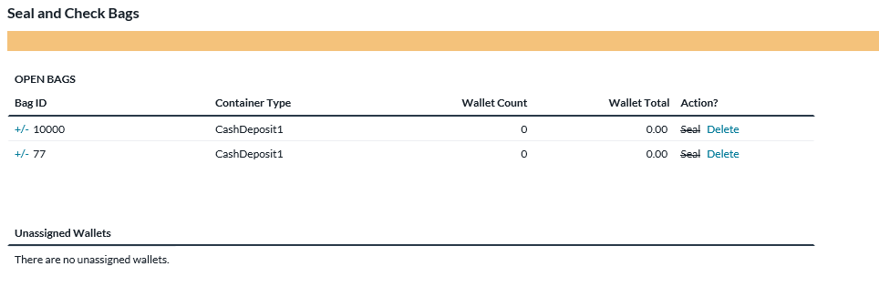

Open Bags section: The upper section of the Seal and Check Bags page provides a list of Outer Container Bags awaiting preparation for transport. Click the ‘+/-‘ hyperlink next to a particular bag to expand or close options for that bag. When options are expanded, a list of Inner Wallets currently within that bag is displayed in the left half, and a list of Inner Wallets eligible for adding to the bag is displayed in the right half. Add or remove wallets as necessary.

Unassigned Wallets section: The lower section of the Seal and Check Bags page provides a list of Inner Wallets not yet assigned to a particular bag. Click the ‘+/-‘ hyperlink next to a particular wallet to assign it to an Outer Container Bag.

After wallets are placed correctly, click the Seal link next to a bag to go on to the next step.

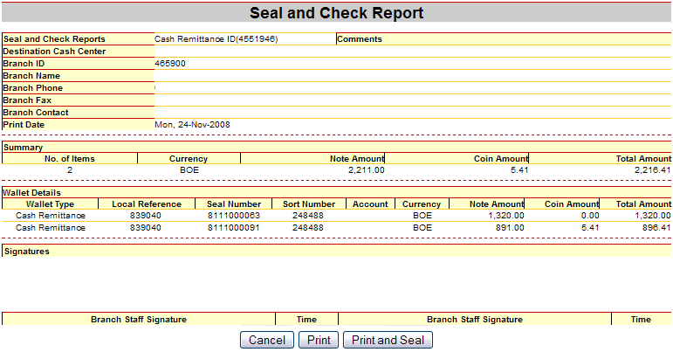

The above report is intended to be printed and placed inside or attached to the Outer Container Bag. Upon pressing the Print and Seal button, the bag will be marked as Sealed and ready for transport.

#### Carrier Pickup

When all bags are prepared, the Carrier Report is provided as printable documentation for the trip. All bags marked as sealed will appear on this page. Use the Print and Mark as Sent button to print copy(s) and mark all of the included bags as Sent.

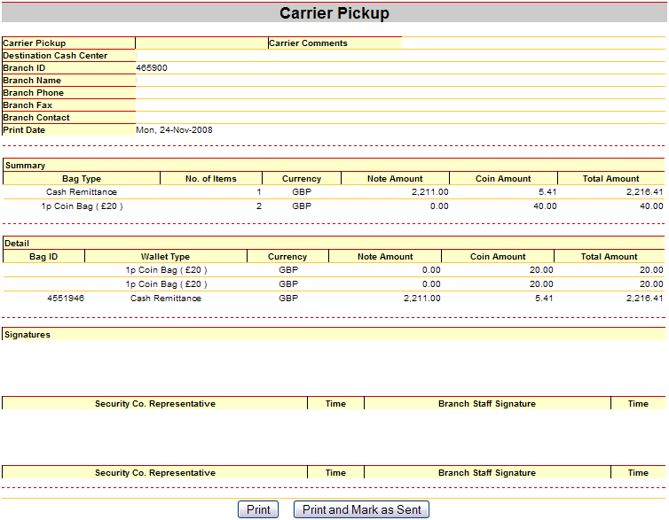

The marking as Sent concludes the typical workflow for OptiNet users wishing to pre-notify returns from their branch.

#### Manage Bags/Wallets

Occasionally, it may be necessary to manage Return Pre-Notification records outside of the normal workflow. The Manage Bags/Wallets page allows users certain management functions:

* Search for entries matching specific criteria
* View the current status and status history of containers
* Change Bag status
* Reprint documentation

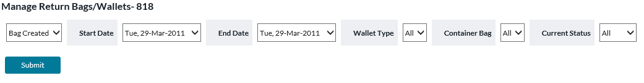

Upon clicking Manage Bags/Wallets in the OptiNet left menu, users are presented with search criteria for selecting desired Return Pre-Notification records.

| Field Name | Description |
| --- | --- |
| Date Application | Bag Created: Search for bags created in the specified date range.  Bag Sealed: Search for bags marked as Sealed during the specified date range.  Bag Sent: Search for bags marked as Sent during the specified date range. |
| Start Date | Beginning of date range to search |
| End Date | End of the date range search |
| Wallet Type | Find records of a specific wallet type |
| Container Bag | Find a specific bag |
| Current Status | Find bags that are currently marked as Open, Sealed, or Sent |
| Currency | The Currency of the notes and/or coins within the Wallet |

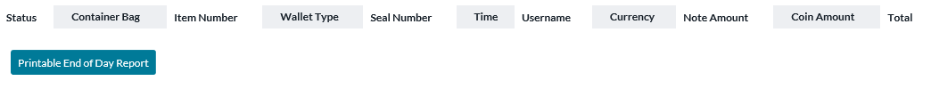

After submitting the search criteria, results are displayed such as above.

| Field Name | Description |
| --- | --- |
| Status | Click on the clipboard icon to review the status history of a particular Bag.  The dropdown menu displays the current status of the Bag. |
| Container Bag | Bag identifier number. Click on the hyperlink for printable documentation for that specific Bag. |
| Item Number | Numbering of Wallets within a particular bag. Sequential (1, 2, 3, …) for each Bag. |
| Wallet Type | The type of wallet. |
| Seal Number | Wallet identifier number. Click on the hyperlink to view more details about the Inner Wallet. |
| Time | Time and date when the Inner Wallet was recorded. |
| Username | The user who recorded the Inner Wallet originally. |
| Currency | The currency of the notes and/or coins included in the wallet. |
| Note Amount | Note amount contained in the wallet. |
| Coin Amount | Coin amount contained in the wallet. |
| Total | The total amount of currency contained in the wallet. |
| Update button | Save any Status changes made via dropdown menus. |
| Printable End of Day Report | Printable report for the displayed bags and wallets. |

### Support Information

Support Information offers a set of useful decision support tools to help you make the best daily decisions for cost-effective currency management work. This support information involves historical data; forecasted cash demands and scheduled deliveries of cash for all your Cashpoints and can be very useful when evaluating the effectiveness of the OptiCash recommendations.

#### Viewing the Demand Horizon

In OptiCash, creating recommendations combines information from forecasts, parameters, requirements, service depot costs, and ending cash position to determine the optimal amount and timing of the next delivery and/or return of cash for each ATM or Branch. Due to the static nature of service schedules, most ATMs and Branches are not eligible for cash deliveries every single day. Using valid delivery schedules and lead times, the system determines which Cashpoints are eligible for ordering cash delivery, determines if such a delivery is required and determines the optimal amount of the delivery. For each Cashpoint, the OptiCash recommendation process produces a 45-day advanced planned horizon that contains scheduled deliveries and returns as well as predicted ATM/Branch cash flows for the next 45 days.

By checking the OptiCash planned horizon for your ATM or Branch, you will have a clear understanding of your current recommendations. Comparing these OptiCash recommendations with the next predicted ones will allow you to decide whether to accept or override them.

1. To view the demand horizon, first select a Cashpoint (ATM or Branch) from the **Cashpoint Selection Window.**
2. Then, click **View Demand Horizon** in the **Navigation Window.**

Figure 27: ATM Horizon Screen

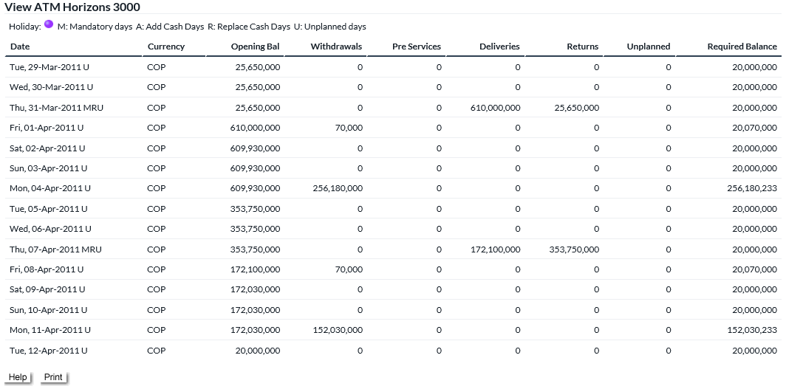

**Note:**  Figure displays single currency horizon for an ATM (add cash, replace or add cash/replace the type of ATM). For recycling ATMs, horizon also includes a field for deposit information.

Figure 28: Branch Horizon Screen

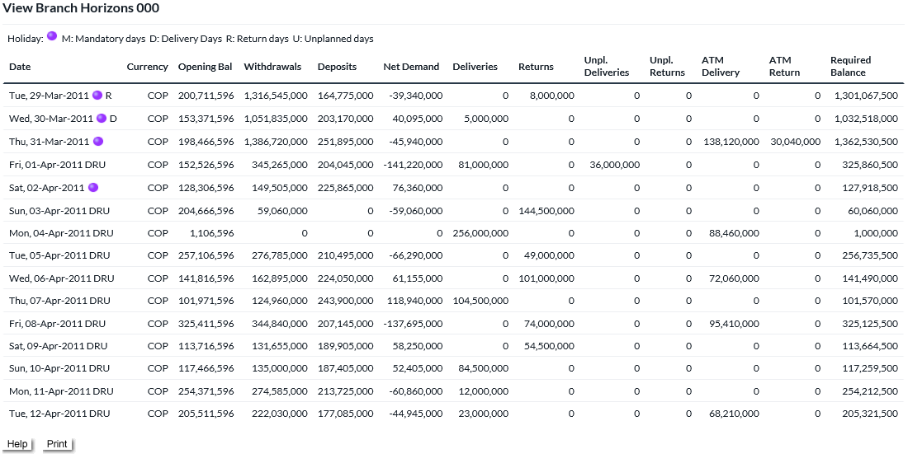

**Note:**  When the horizon includes multiple currencies, a record for each currency is displayed.

The information presented in the horizon is described in more detail in the following table:

| ATM Horizon Details | |
| --- | --- |
| Date | The date for which the balance details are displayed. |
| Currency | Currency for which the balance details are displayed. |
| Opening Balance | The initial balance represents the last load balance load during the load process. |
| Withdrawals | The amount representing customer withdrawals. |
| Deposits (recycle ATMs only) | For recycle ATMs only, this amount represents customer deposits. |
| Pre-Services | The withdrawal amount during the service day before a carrier arrives. |
| Deliveries | Planned deliveries and committed orders. |
| Returns | For replace or recycle ATMs, returns represent the amount of cash returned. |
| Unplanned | Emergency delivery is triggered when the opening balances are under the required balance. |
| Branch Horizon Details | |
| Date | The date for which the balance details are displayed. |
| Currency | Currency for which the balance details are displayed. |
| Opening Balance | The initial balance represents the last load balance load during the load process. |
| Withdrawals | The amount representing customer withdrawals. |
| Deposits | The amount representing customer deposits. |
| Net Demand | Total withdrawals subtracted by deposits. |
| Deliveries | Planned deliveries and committed orders. |
| Returns | For Branches, returns represent the amount of cash returned. |
| Unplanned Deliveries | Emergency delivery is triggered when the opening balances are under the required balance. |
| Unplanned Returns | Emergency return triggered when the opening balances are over maximum holding. |
| ATM Normal Delivery | For the branches with linked ATMs, this field displays the total amount of planned deliveries for the linked ATMs. |
| ATM Unplanned Delivery | For the branches with linked ATMs, this field displays the total amount of unplanned deliveries for the linked ATMs. |
|  | **Note**: when the branch has linked ATMs with linkage attributes defined as ‘Linked Balances’, the balance and demand information will contain the total amounts of the linked ATMs. |

#### Viewing the Linked Horizon

The Linked Horizon supplies essentially the same data as the Demand Horizon report, but it offers details for the individual Balance Accounts maintained at the branch and tracked in OptiCash/Optinet.

Figure 29: Branch Horizon Screen

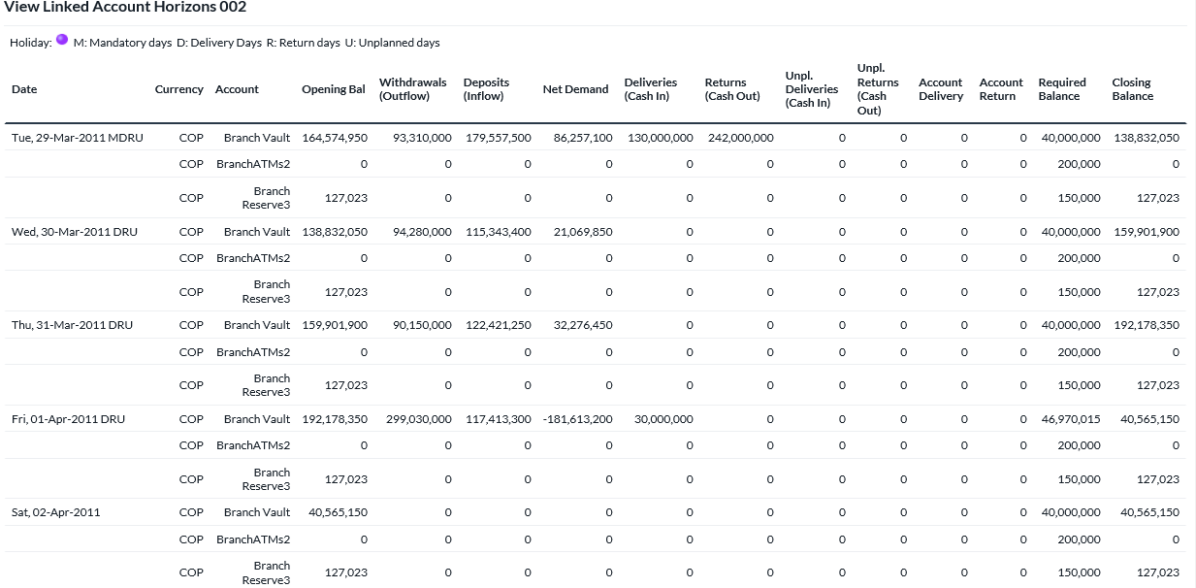

| Branch Linked Horizon Details | |
| --- | --- |
| Date | The date for which the order details are displayed. |
| Currency | Currency for which the order details are reported. |
| Account | Balance Accounts to be reported |
| Open Bal | The starting balance represents the closing balance of the last day. |
| Withdrawals (Outflow) | Represent forecasted customer withdrawals. |
| Deposits (Inflow) | Represent forecasted customer deposits during that date. |
| Net Demand | Difference between Withdrawals (Outflow) and Deposits (Inflow) |
| Deliveries (Cash In) | Planned deliveries for that date. |
| Returns (Cash Out) | For branches and replacement or recycling ATMs represent the amount of cash to be returned (forecasted value). |
| Unplanned Deliveries (Cash In) | Emergency delivery is triggered when the opening balances are under the required balance. |
| Unplanned Returns (Cash Out) | Emergency return is triggered when the opening balances are over the maximum holding. |
| Account Delivery | Delivery total for the full branch reflecting a sum of the individual account deliveries |
| Account Return | Return total for the full branch reflecting a sum of the individual account returns |
| Required Balance | Required calculated inventory at the beginning of the day. |
| Closing Balance | Closing balance at the end of the day. |

#### Viewing History

##### ATM History

In OptiCash, historical ATM data is used as input for the forecasting engine so that accurate cash demand forecasts for future periods are possible. Ideally, the historical data should be from the preceding twelve months or similar to the period being forecasted but frequently, when preparing to implement the system, twelve months of historical demand data is not readily available. In this case, it is possible to implement the system and achieve accurate results with as little as three months of historical demand data.

Once running in production using OptiCash, additional demand data is captured on a daily basis when loading balance files containing actual demand and closing balance amounts. Over time, this increases the population of historical demand data, which will be useful for the forecasting process to predict future demand as well as for analysis purposes.

The historical data displayed will provide you with access to your ATM's actual ending cash position as well as recent amounts of cash deliveries and returns. This information can be used to verify the quality of the OptiCash recommendations. You can also compare the most recent forecasted withdrawals vs. actual, in order to evaluate forecast effectiveness.

1. To view ATM history, first select an ATM from the **Cashpoint Selection Window.**
2. Then, click **View History** in the **Navigation Window.**

For ATMs, the following information is displayed: Opening Balance, Withdrawals, Pre-Service Withdrawals, Deliveries/Returns, Closing Balance and Status. An example of an ATM History is provided in the figure below:

Figure 30: ATM History Screen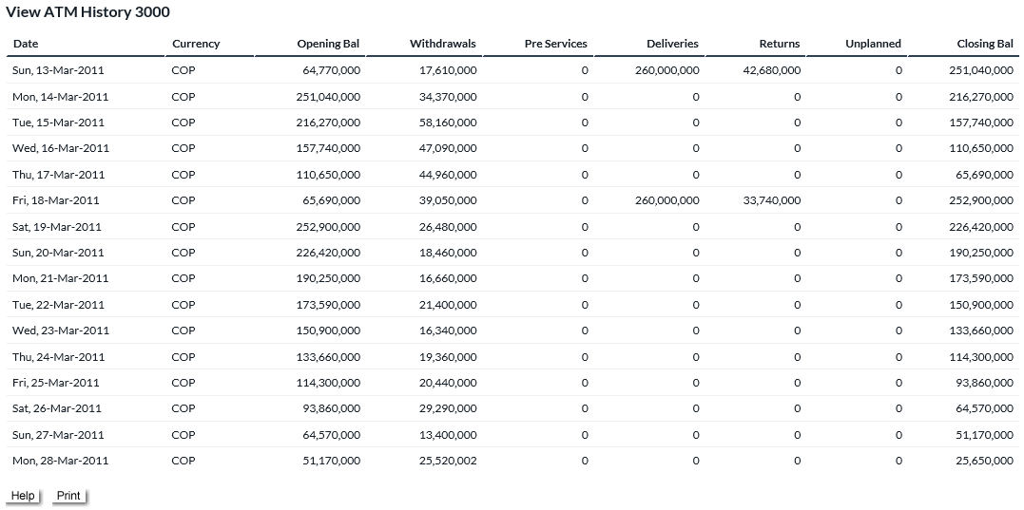

|  |  |
| --- | --- |
|  | **Note:**  Figure displays single currency history for an ATM. When history includes multiple currencies, a record for each currency is displayed. |

The information presented in the horizon is described in more detail in the following table:

| ATM History Details | |
| --- | --- |
| Date | The date for which the balance details are displayed. |
| Currency | Currency for which the balance details are displayed. |
| Opening Balance | The initial balance represents the last load balance load during the load process. |
| Withdrawals | The amount representing customer withdrawals. |
| Deposits (Advanced Device ATMs only) | This amount represents customer deposits. |
| Pre-Services | The withdrawal amount during the service day before a carrier arrives. |
| Deliveries | Planned deliveries and committed orders. |
| Returns | The amount of cash returned to the funding source. |
| Unplanned | Delivery performed on an unplanned or emergency schedule. |
| Closing Balance | Closing balance at the end of the day. |
| Dispense (Advanced Device ATMs only) | The amount available in the cassette is configured only to dispense notes. |
| Recycle (Advanced Device ATMs only) | The amount available in the cassette is configured to receive deposits and can dispense as withdrawals. |
| Cash-In (Advanced Device ATMs only) | The amount available in the cassette is configured to receive deposited notes only and cannot be used by the machine to dispense as a withdrawal. |
| Status | Indicates whether an ATM is operational (open or closed) during this particular day. |

##### Branch History

In OptiCash, historical Branches data is used as input for the forecasting engine so that accurate cash demand forecasts for future periods are possible. Branches history is updated day by day in OptiCash loading the Branch Balance Daily File, with actual demand and closing balance amounts. This branch's historical data will be useful for the forecasting process to predict future withdrawals, deposits, and net demand, as well as for analysis purposes.

The OptiNet View Branch History option will let you see the historical data for a Branch selected from the Cashpoint selector list. Seeing historical data, you will have access to your Branch's actual ending cash position as well as recent amounts of cash deliveries and returns. If you have been following OptiCash recommendations, you will find out if the most recent historical cash positions have been good enough to encourage you to keep following OptiCash recommendations for your Branch currency management. You can also compare the most recent forecasted withdrawals, deposits and net demand with the actual ones, to evaluate forecast effectiveness.

1. To view ATM history, first select an ATM from the **Cashpoint Selection Window.**
2. Then, click **View History** in the **Navigation Window.**

For branches, the following information is displayed: Currency, Opening Balance, Withdrawals, Deposits, Net Demand, Deliveries, Returns, and Closing Balance. An example of a Branch History is provided in the figure below:

Figure 31: Branch History Screen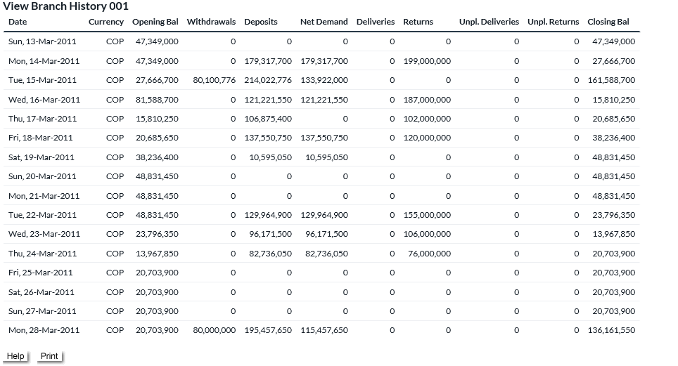

|  |  |
| --- | --- |
|  | **Note:**  Figure displays single currency history for an ATM. When history includes multiple currencies, a record for each currency is displayed. |

The following table explains the fields in the Branch History Window in more detail.

| Branch History Details | |
| --- | --- |
| Date | The date for which the balance details are displayed. |
| Currency | Currency for which the balance details are displayed. |
| Opening Balance | The initial balance represents the last load balance load during the load process. |
| Withdrawals | The amount representing customer withdrawals. |
| Deposits | The amount representing customer deposits. |
| Net Demand | Total withdrawals subtracted by deposits. |
| Deliveries | Planned deliveries and committed orders. |
| Returns | For Branches, returns represent the amount of cash returned. |
| Unplanned Deliveries | Emergency delivery is triggered when the opening balances are under the required balance. |
| Unplanned Returns | Emergency return triggered when the opening balances are over maximum holding. |
| Closing Balance | Closing balance at the end of the day. |

##### Branch Linked History

The Linked History supplies essentially the same data as the Branch History report, but it offers details for the individual Balance Accounts maintained at the branch and tracked in OptiCash/Optinet.

Figure 32: Branch Linked History Screen

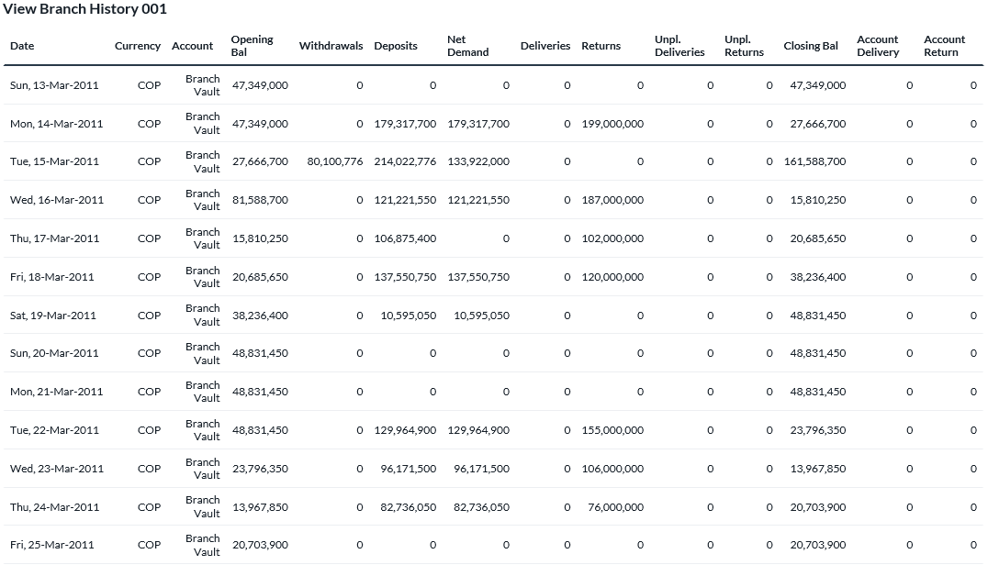

| Branch Linked History Details | |
| --- | --- |
| Date | The date for which the history details are displayed. |
| Currency | Currency for which the history details are reported. |
| Account | Balance Account for which the history details are reported |
| Open Bal | The starting balance represents the closing balance of the last day. |
| Withdrawals (Outflows) | Reduction of the account balance through the outflow |
| Deposits (Inflows) | Increase of the account balance through the inflow |
| Net Demand | Difference between Withdrawals and Deposits |
| Deliveries (Cash In) | Planned deliveries for that date. |
| Returns (Cash Out) | For branches and replacements, ATMs represent the amount of cash returned. |
| Unplanned Deliveries (Cash In) | Emergency delivery is triggered when the opening balances are under the required balance. |
| Unplanned Returns (Cash Out) | Emergency return is triggered when the opening balances are over the maximum holding. |
| Account Delivery | Delivery total for the full branch reflecting a sum of the individual account deliveries |
| Account Return | Return total for the full branch reflecting a sum of the individual account returns |
| Closing Balance | Closing balance at the end of the day. |

#### Viewing Forecasts

Forecasting is an OptiCash process that uses historical data to predict or estimate amounts of future occurrences. OptiNet allows you to view these forecasts for each Cashpoint in your network.

##### ATM Forecasts

For ATMs, the data being forecasted is withdrawals. The OptiCash forecasting algorithm uses a complex set of variables including holidays, events, day of the week, week of the month, etc. to achieve accurate predictions.

The OptiCash forecasting process for ATMs generates a graph and some additional information related to the predicted withdrawals. In the forecast graph, each point is related to a specific date, and for ATMs, each point represents a withdrawal amount. Two values are plotted in the graph:

* The **blue line** represents **actual data**: in effect, these are the withdrawals loaded from the daily balance files
* The **red line** represents **forecasted data**. These are the predicted withdrawals based on historical demand, costs and future events.

A sample of an OptiNet ATM Forecast graph is provided in the figure below. OptiNet displays the past two weeks of historical data (actual vs. forecast), as well as withdrawal predictions for the next two weeks. Using this graph, you can gain insight into how well OptiCash is predicting withdrawals for each ATM.

Figure 33: ATM Forecast Screen

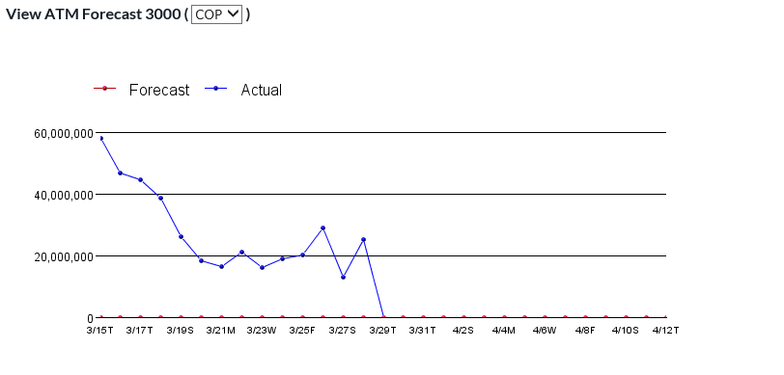

|  |  |
| --- | --- |
|  | **Note**: To display the forecast graph for different currencies, select a desired currency from the drop-down list at the top of the screen. |

The OptiCash forecasting process for Advanced Device ATMs generates three different graphs that are displayed in OptiNet. In these forecast graphs, each point is related to a specific date. A summary of the graph types is presented in the table below:

| Adv Device Graph Type | Graph Description |
| --- | --- |
| Net Demand Forecast Graph | Each point on the graph represents the net demand amount for the selected date. |
| Withdrawals Forecast Graph | Each point on the graph represents a withdrawal amount for the referenced date. |
| Deposits Forecast Graph | Each point on the graph represents a deposit amount for the referenced date. |

A sample of an Advanced Device ATM Forecast graph for Net Demand is provided in the figure below. OptiNet displays the past two weeks of historical data (actual vs. forecast), as well as withdrawal predictions for the next two weeks.

Figure 34: Advanced Device ATM Forecast Screen (Net Demand)

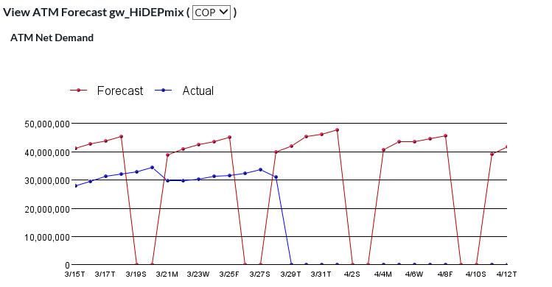

##### Branch Forecasts

The OptiCash forecasting process for Branches generates three different graphs that are displayed in OptiNet. In these forecast graphs, each point is related to a specific date. A summary of the graph types is presented in the table below:

| Branch Graph Type | Graph Description |
| --- | --- |
| Withdrawals Forecast Graph | Each point on the graph represents a withdrawal amount for the referenced date. |
| Deposits Forecast Graph | Each point on the graph represents a deposit amount for the referenced date. |
| Net Demand Forecast Graph | Each point on the graph represents the net demand amount for the selected date |

Branch forecast graphs are plotted using two color-coded values.

* The **blue line** represents **actual data**: in effect, withdrawals, deposits or net demand, loaded from the daily files.
* The **red line** represents **forecasted data**. These are the predicted withdrawals, deposits or net demand, based on historical demand, costs and future events.

A sample of an OptiNet Branch net demand forecast graph is provided in the figure below. OptiNet displays the past two weeks of historical data (actual vs. forecast) as well as withdrawals, deposits or net demand predictions for the next two weeks. Using this graph, you can gain insight into how well OptiCash is predicting withdrawals, deposits and net-demand for each branch.

Figure 35: Branch Forecast Screen (Net Demand)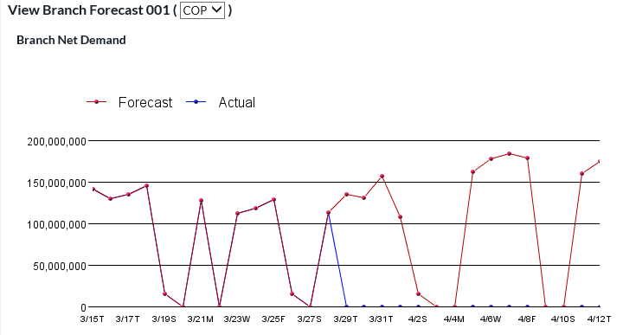

|  |  |
| --- | --- |
|  | **Note**: To display the forecast graph for different currencies, select a desired currency from the drop-down list at the top of the screen. |

#### Viewing Orders

1. To view Orders history, first select a Cashpoint from the **Cashpoint Selection Window.**
2. Then, click **View Orders** in the Navigation Window under **Support Information**.

Figure 36: View Orders Page

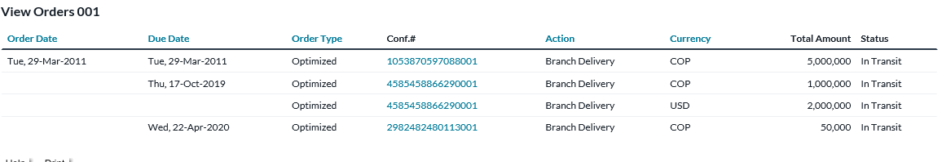

The following table explains the fields in the View Orders window in more detail. Note: Clicking on the Column headers will allow the report to be sorted by the selected column.

| View Orders | |
| --- | --- |
| Order Date | The date on which the order was committed through OptiCash or OptiNet. |
| Due Date | The date on which the order was to be delivered. |
| Order Type | Describes the type of order being placed:  Optimized – Normally recommended currencies  Self-Managed – Foreign Currencies |
| Conf # | A unique identifier for this order. Clicking the hyperlink goes to the order details screen. |
| Action | The type of service ordered. |
| Currency | The currency is being moved as part of this order. |
| Total Amount | The total amount of cash moved as part of this order. |

#### Viewing Disputes

1. To view Disputes history, first select a branch Cashpoint from the **Cashpoint Selection Window.**
2. Then, click **View Disputes** in the Navigation Window under **Support Information**.

Figure 37: View Disputes Page

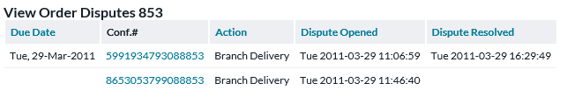

The following table explains the fields in the View Disputes window in more detail. Note: Clicking on the Column headers will allow the report to be sorted by the selected column.

| View Disputes | |
| --- | --- |
| Due Date | The date on which the order was to be delivered. |
| Conf. # | A unique identifier produced for this order. Clicking the hyperlink goes to the order details screen. |
| Action | The type of order. Branch Return, Branch Delivery, etc. |
| Dispute Opened | Date and time when the dispute was first opened for this order. |
| Dispute Resolved | Date and time when dispute resolved, or empty if not resolved. |

#### INPUT DISPUTEs

1. To Input Disputes, first, select a Branch Cashpoint or the “ALL Branches” from the **Cashpoint Selection Window.**
2. Then, click **Input Disputes** in the Navigation Window under **Support Information**.

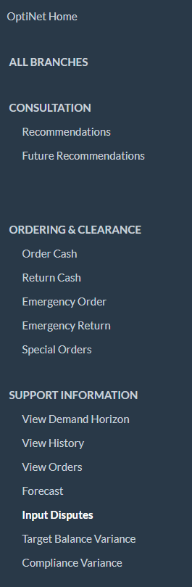

Input Disputes shows all Branch Delivery Orders (planned and unplanned). Users may use filters to search for confirmed, or disputed orders and click to view additional details of a particular order if desired. Users can also view the manifest, and click to create/update dispute details for an order.

| Input Disputes | |
| --- | --- |
| Due Date | The date on which the order was to be delivered. |
| Order Date | The date on which this order was created. |
| Order Reference | The reference for the particular order. |
| Status | The order state (Confirmed, Disputed) |

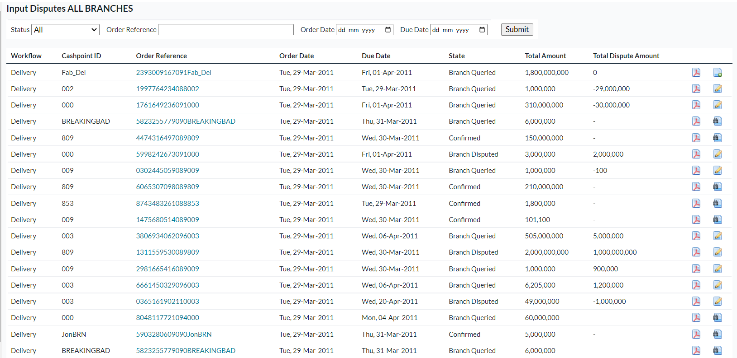

Users can click on the order reference to go to the order screen and click on the Count Issue task to change the order state to Queried and then click on Edit task to enter the amount received and the difference from the actual ordered value vs the received amount will be calculated and saved as the disputed amount.

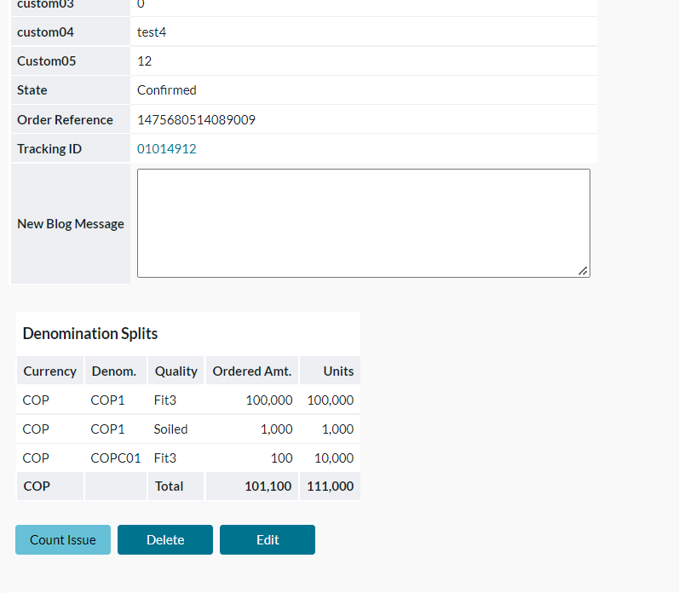

Create/Update Dispute Details

Users can click on create dispute or update dispute icon to enter dispute details or update them respectively along with supporting evidence so that the total amount of dispute matches the earlier calculated dispute amount and save dispute details.

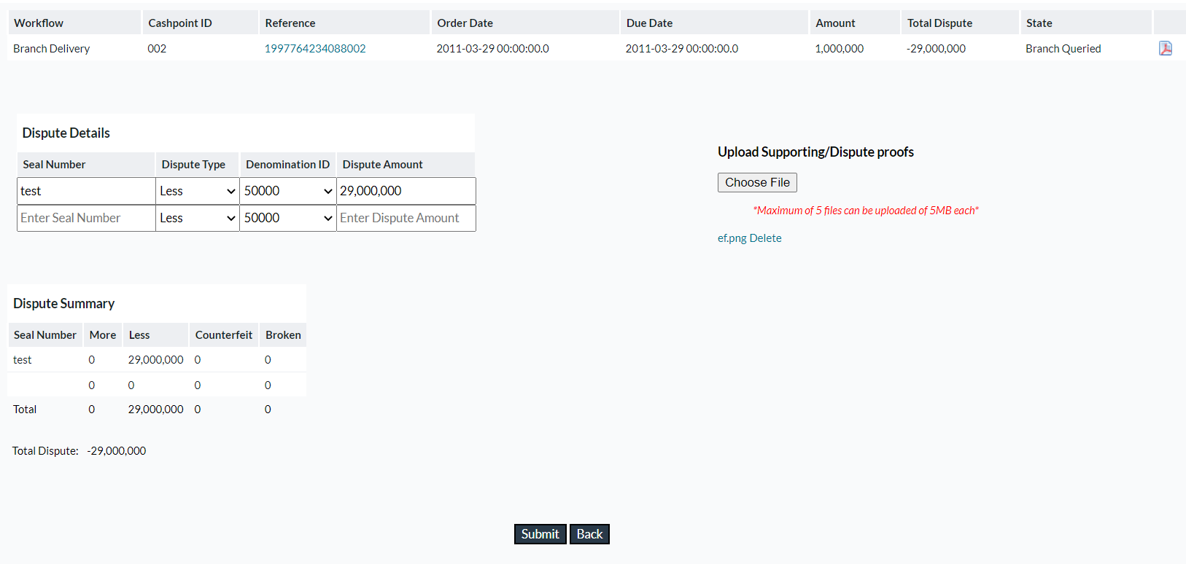

Depending on the edit made in Optinet to branch delivery orders the disputed amount (amount difference between the actual order and edited order) will be calculated and fixed which we can see in this image in the order detail table’s Total Dispute field.

After receiving the order, Optinet users can populate the details in the Dispute Detail table which then generates the Dispute Summary table in real-time. Evidence of these disputes can also be attached as an image or pdf file type.

|  |  |
| --- | --- |
| Field | Description |
| Seal Number | Individual order seal bag identifier. |
| Dispute Type | Dropdown to select dispute type. By default, the 4 available dispute types are: -   * More: If the amount exceeds compared to what is declared in the manifest. * Less: If the amount is less compared to what is declared in the manifest. * Counterfeit: If the received currency bills are invalid. * Broken: If the bills received are not in proper condition and therefore are not usable. |
| Denomination Id | Dropdown to select a denomination id from Cashpoint level defined denominations. |
| Dispute Amount | Numeric Text Field to enter the disputed amount for the given bag id, denomination id and dispute type. |

The Dispute Summary table shows the different amounts of disputes of all types for each bag ID, and the total dispute amount is also shown below this table.

The Save button will only be enabled if the total dispute amount below the dispute summary table matches the amount in the Total Dispute column at the top of the screen.

#### View ATM Utilization

ATM utilization is a report that allows the user to determine how successfully the funds have been utilized for an ATM. The effectiveness is expressed by the cash utilization percentage per delivery cycle and indicates the rate at which cash is utilized against the total cash available at the Cashpoint during the selected delivery cycle. The following are the details on how the utilization rate is calculated:

|  |
| --- |
| Replace ATM Utilization: |
| Utilization % = Cycle Demand / Cycle Delivery * 100  Cycle Demand = Post_Service_Withdrawals[day0] + Withdrawals[day1] + Withdrawals[day2] + ... + Withdrawals[dayN -1 ] + Pre_Service_Withdrawals[dayN]  Cycle Delivery = The delivery amount at the beginning of the cycle |
| Add Cash ATM Utilization: |
| Utilization % = Cycle Demand/(Pre-Delivery Balance + Cycle Delivery) * 100   Cycle Demand = Post_Service_Withdrawals[day0] + Withdrawals[day1] + Withdrawals[day2] + ... + Withdrawals[dayN -1 ] + Pre_Service_Withdrawals[dayN]  Pre-Delivery Balance = Opening Balance – Pre Service Withdrawals  Cycle Delivery = The delivery amount at the beginning of the cycle |

1. To view ATM utilization, first select an **ATM** from the **Cashpoint Selection Window.**
2. Then click View Utilization in the Navigation Window under Support Information.

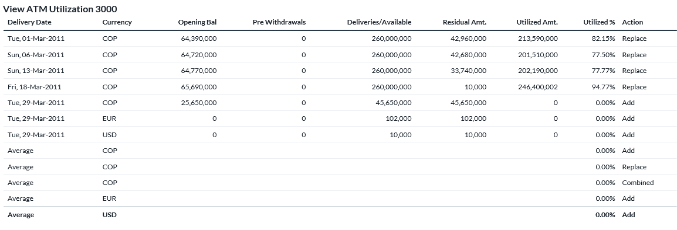

The following table explains the fields in the View Utilization window in more detail.

| View Utilization | |
| --- | --- |
| Delivery Date | The date on which delivery was made |
| Currency | The currency in use. |
| Opening Balance | The opening balance of the ATM on the date in question. |
| Pre Withdrawals | Customer withdrawals are processed during the day and prior to the arrival of the delivery. |
| Deliveries/Available | Total available cash in the ATM at the beginning of the delivery cycle:  For Replace ATMs:  Deliveries/Available = Delivery Amount at the beginning of the cycle.  For Add Cash ATMs:  Deliveries / Available = Opening Balance – Pre Withdrawals + Delivery Amount |
| Residual Amount | For Replace ATMs:  Residual Amount = Return Amount at the end of the delivery cycle.  For Add Cash ATMs: a balance left from the previous delivery is to be forwarded to the next delivery cycle.  Residual Amount = Delivery Amount – Utilized Amount; |
| Utilized Amount | The utilized amount is the cycle demand or the total amount that has been withdrawn from the Cashpoint during a delivery cycle: from today’s delivery to the next delivery day.  Utilized Amount = Post_Service_Withdrawals[day0] + Withdrawals[day1] + Withdrawals[day2] + ... + Withdrawals[dayN -1 ] + Pre_Service_Withdrawals[dayN]; |
| Utilized % | The percentage of utilization indicates the difference between the delivered/ Available Amount and the Utilized Amount.  Utilized % = Utilized Amount / ‘Deliveries & Available’ * 100 |
| Action | Type of delivery action performed. Ex: ‘Add Cash’ or ‘Replace Cash’. |

#### Target Balance Variance

Target Balance Variance provides a day-to-day variance report comparing targeted balances to actual (historical) balances. Targeted Balances are generated at the beginning of each month and stored. Actual balances are compared to them thus generating the variance %. This provides a day-to-day graphical performance indicator to the branch user.

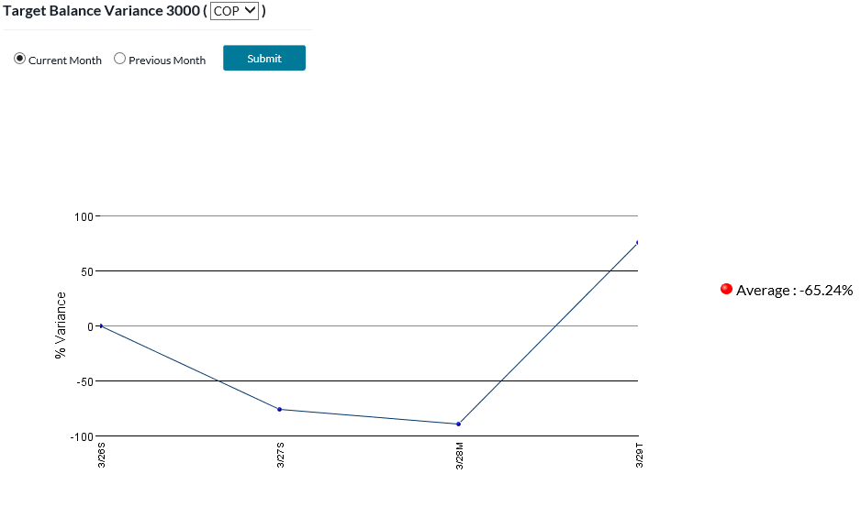

| Target Balance Variance | |
| --- | --- |
| Currency | The currency in use. |
| Current Month | Automatically defaults to the full calendar month in which the current date falls |
| Previous Month | Automatically defaults to the full calendar month prior to the one in which the current date falls |
| User Selected | OptiNet users will designate the date range to be shown in the graph |
| Average | Average Variance of Targeted Balance vs. Historical Balance |
| Lower Band | Administrator-set Lower acceptable limit for variance |
| Upper Band | Administrator-set Upper acceptable limit for variance |

#### Compliance Variance

Compliance Variance provides a day-to-day graphical variance report comparing recommended deliveries/returns to actual (historical) deliveries/returns.

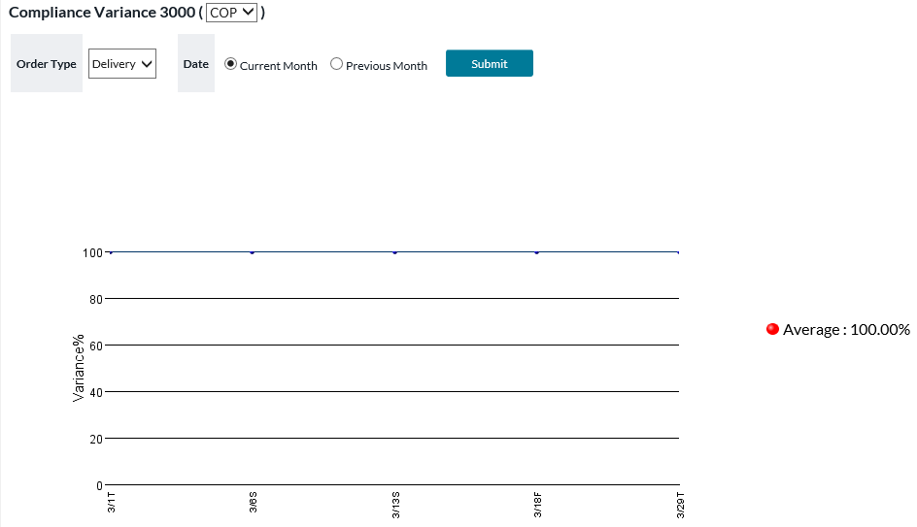

| Compliance Variance | |
| --- | --- |
| Currency | The currency in use. |
| Action ID | The user selects which metric to review. Deliveries for ATMs. Deliveries or Net Demand (Delivery-Returns) for Branches |
| Schedule ID | Normal (deliveries on standard scheduled days) Normal/Emergencies (deliveries on both standard days and non-standard days) |
| Current Month | Automatically defaults to the full calendar month in which the current date falls |
| Previous Month | Automatically defaults to the full calendar month prior to the one in which the current date falls |
| User Selected | OptiNet users will designate the date range to be shown in the graph |
| Average | Average Variance of Targeted Balance vs. Historical Balance |
| Lower Band | Administrator-set Lower acceptable limit for variance |
| Upper Band | Administrator-set Upper acceptable limit for variance |

#### Carrier Catalog

Carrier Catalog allows a Branch user to view detailed info about Carrier Employees. This can be used for the verification of credentials. Please note that this function is only available when OptiVLM CarrierWeb is in use and reachable by the OptiNet system.

Figure 38: Navigation Window – Choose Carrier

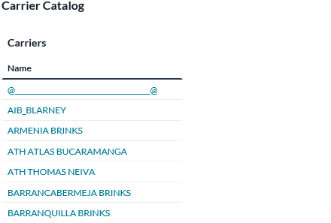

Figure 39: Carrier Catalog – Employees List Screen

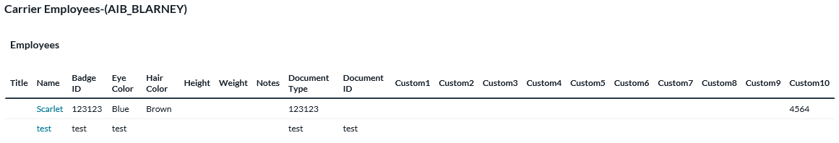

| Field | Description |
| --- | --- |
| Title | Employee’s title. |
| Name | Employee’s name. Click to view the picture. |
| Badge ID | Employee’s Badge ID. |
| Eye Color | Employee’s eye color. |
| Hair Color | Employee’s hair color. |
| Height | Employee’s height |
| Weight | Employee’s weight |
| Notes | Notes associated with this Employee. |
| Document Type | The type of identifying document for this Employee. The actual value of this identifier appears in the next field, Document ID. |
| Document ID | ID for this Employee of the type specified in the preceding Document Type field. |
| Custom 1 to 10 | Fields whose meanings can be customized by your institution. |

# Depot User

The Depot user, upon logging in, will immediately see a confirmation list of all the depots for which he/she is responsible, and for which there are orders waiting to be confirmed. Each depot is a hyperlink and the resulting screen will display the cash orders, by Cashpoint, for that depot. These orders should always be printed and then to complete the process, the depot electronically “acknowledges” that the order has been received. The process is then repeated for all the remaining depot orders.

The **Navigation Window** for Depot Users is displayed below:

Figure 40: Navigation Window – Depot User

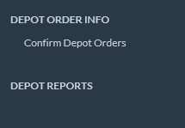

### Confirming Depot Orders

1. To confirm a depot order, the Depot User will begin by clicking the underlined hyperlink for each depot on the *Depot Confirmation List* screen. An example of this screen is displayed in the figure below:

Figure 41: Sample Depot Confirmation List

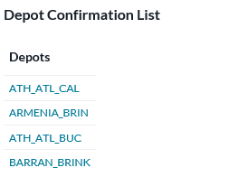

1. After selecting a depot to confirm, the Depot User will be presented with a list of Cashpoints serviced by that depot and the cash order for each. A sample Cashpoint order is presented in the figure below:

Figure 42: Depot Confirm Cashpoint Order Detail

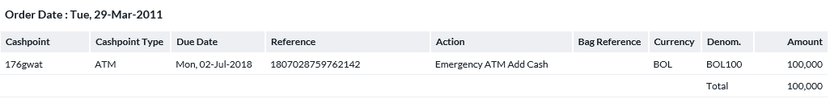

1. Note the fields in the following table:

Table 7: Create Historical Order Fields

| Field | Description |
| --- | --- |
| Cashpoint ID | Unique alphanumeric value for identification of the Cashpoint. |
| Cashpoint Type | Type of Cashpoint: branch or ATM. |
| Due Date | Due date of the order delivery. |
| Reference | Order reference number. |
| Action | For an ATM it will be Add Cash or Replace, whereas for branches Delivery or Return. |
| Bag Reference | Bag Reference number will only be displayed for branch returns. |
| Currency | Currency for this order. |
| Denomination | Denominations for this order. |
| Amount | Amount ordered. |

1. Scroll down to the last Cashpoint order on the screen.
2. Click **Print** to print the Cashpoint order details for each Cashpoint.

|  |  |
| --- | --- |
|  | Caution: Always print the orders before going to the next step. Once the depot order has been confirmed, you will not be able to return to the order detail to reprint. |

1. To confirm the order, click **Depot Confirm.**
2. Once the depot has been confirmed, the following window will be displayed:

Figure 43: Depot Confirm Screen

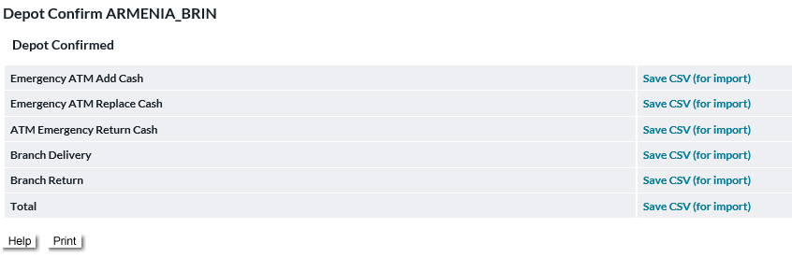

1. Click on the hyperlinks to save the order details by action as a CSV format for your records.

### Depot History

To review depot history, click **Depot History** in the **Navigation Window** on the left. The depot history will be displayed for all depots managed by this Depot User. A sample of the depot history is displayed in the figure below.

Figure 44: Depot History Screen

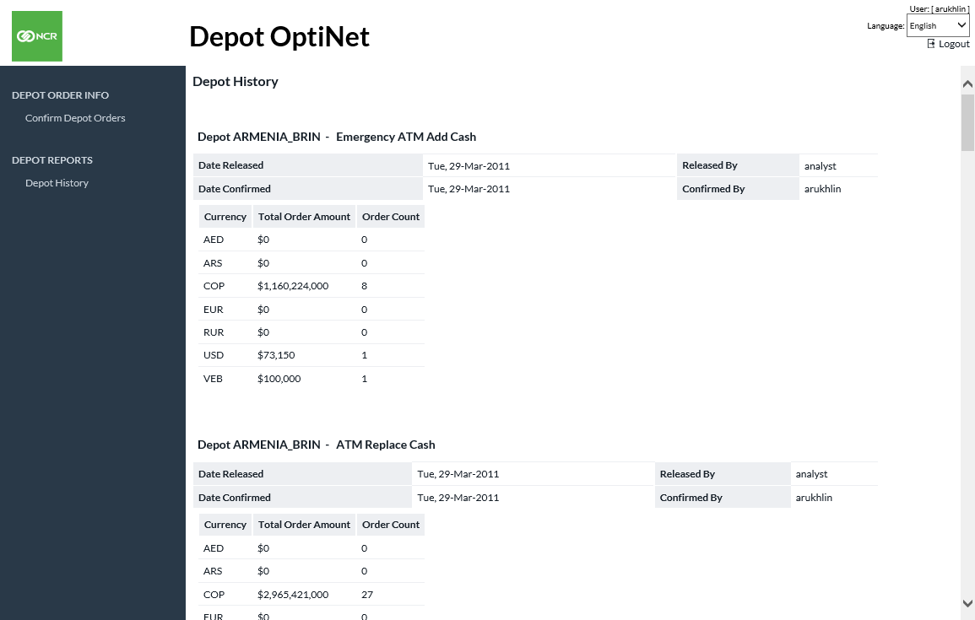

# Security And Authentication

## OptiNet Authentication Options

OptiNet provides three methods of user authentication: Internal, external, and custom. An overview of each is provided below.

### Internal

When internal authentication is in use, OptiNet uses a simple username/password scheme implemented using JSP screens and the database. The sole purpose of internal authentication is to provide for easy demonstration installations and functional testing. Since the passwords are transmitted and stored in the clear this is not an appropriate method for a production environment.

Users are presented with a simple web form requesting their username and password. When they enter them and submit the form, OptiNet looks for a username/password match in its database. If the user exists and the account is not locked, they are allowed access to the system. If not, they receive a rejection message on the web form and are allowed to try again. There is no limit on the number of tries, no limit on the quality or lifespan of a password, and no way for the user to change their password.

### External

External authentication relies entirely on the web server, application server and operating system to handle user authentication, something they do very well. OptiNet simply maintains a relationship between an external authenticated user and an OptiNet user definition. This form of authentication is most commonly recommended for production environments, allowing highly secure authentication and providing for at least minimal if not enterprise-wide shared authentication management.

The OptiNet application is configured within the application server and/or web server as a secure application. When a user attempts to use it, the servers reject the browser request indicating credentials are required, and what type(s) of credentials are acceptable. The browser provides an operating system secure login dialogue prompting the user for their credentials, whether that is a username and password or a digital certificate. Once the browser has securely acquired credentials, it retries the request including proof of these credentials in the form of a password digest, digital signature, etc. The server maps these credentials to a username and authentication type, and if they are authorized to use the application at all, allows the request to reach OptiNet. OptiNet retrieves the username and authentication type from the server for the request and maps that to authorization information for that user on its database.

### Custom

Custom authentication allows for non-standard authentication of users in a reasonably secure manner. This method relies on the same login web form as internal authentication but hands the username and password to a custom class for validation. This returns a successfully authenticated username, a retry message, or the URL of a rejection form. The login web form can display an optional message, making it a good destination for authentication failure with a retry allowed. If the authentication failure requires a password change or is a flat rejection with no retry allowed, the URL of a custom web form to handle these situations must be returned.

Users are presented with a simple web form requesting their username and password. When they enter them and submit the form, OptiNet passes the username and password into the authentication method of an instance of the custom authentication class. If the method indicates a successful login, OptiNet retrieves the username and authentication type from the custom authentication class and maps that to authorization information for that user on its database. If the authentication method indicates failure, then OptiNet retrieves either a retry message or a failure URL from the custom authentication class. If it gets a retry message, OptiNet will simply redisplay the login web form, including the retry message. If instead, it gets a failed URL, OptiNet forwards the browser to that URL. Note that the URL need not be on the same server. From a security point of view, this exposes clear passwords in both transmission and memory. It also exposes a more significant possibility of class spoofing than the external authentication method. Using SSL and heavily securing the client and server machines can mitigate these exposures.

# Customizing OptiNet

## Customizing the ‘Look and Feel’

It is possible to customize the fonts and certain colors in the OptiNet application. This customization process is discussed in the OptiNet deployment documentation. Your NCR Cash Management representative can provide this documentation to you upon request.

## Multi-Language Support

Multi-language support is available for OptiNet. This option is set in the application customization area, under System Settings and Setup and details are provided in the OptiNet deployment documentation.

CXBanking, OptiNet, User Reference Guide

Version 10.0

March 2023

NCR welcomes your feedback on this document. Your comments can be of great value in helping us improve our information products. Please contact us using the following address:

[email: xxxx@yyyy]

[web: <https://xxx.xxx.xxx>]